Lenin on War and Private Property
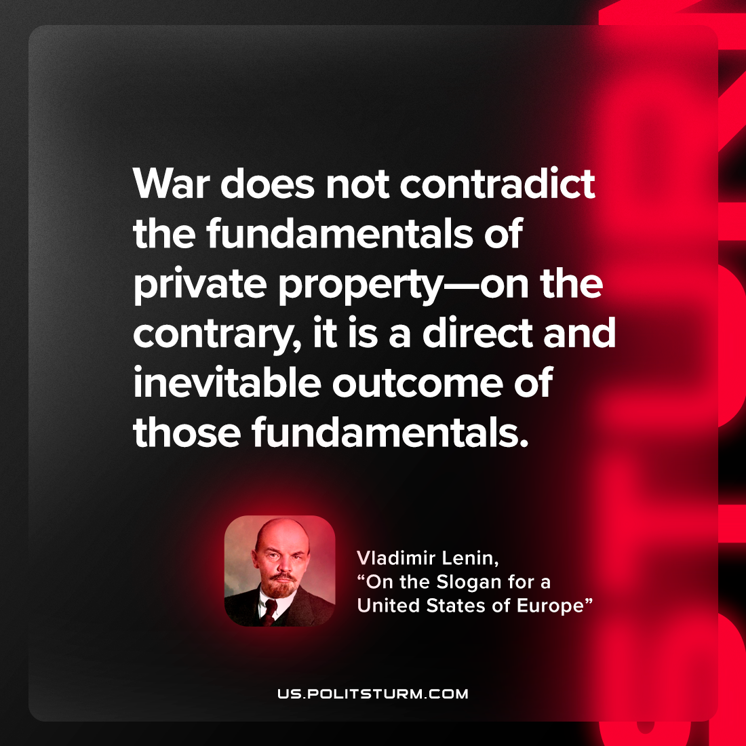

Original article
2022-12-22

"War does not contradict the fundamentals of private property—on the contrary, it is a direct and inevitable outcome of those fundamentals."
Vladimir Lenin, “On the Slogan for a United States of Europe”

Original article

