Lenin on Wage Bribery
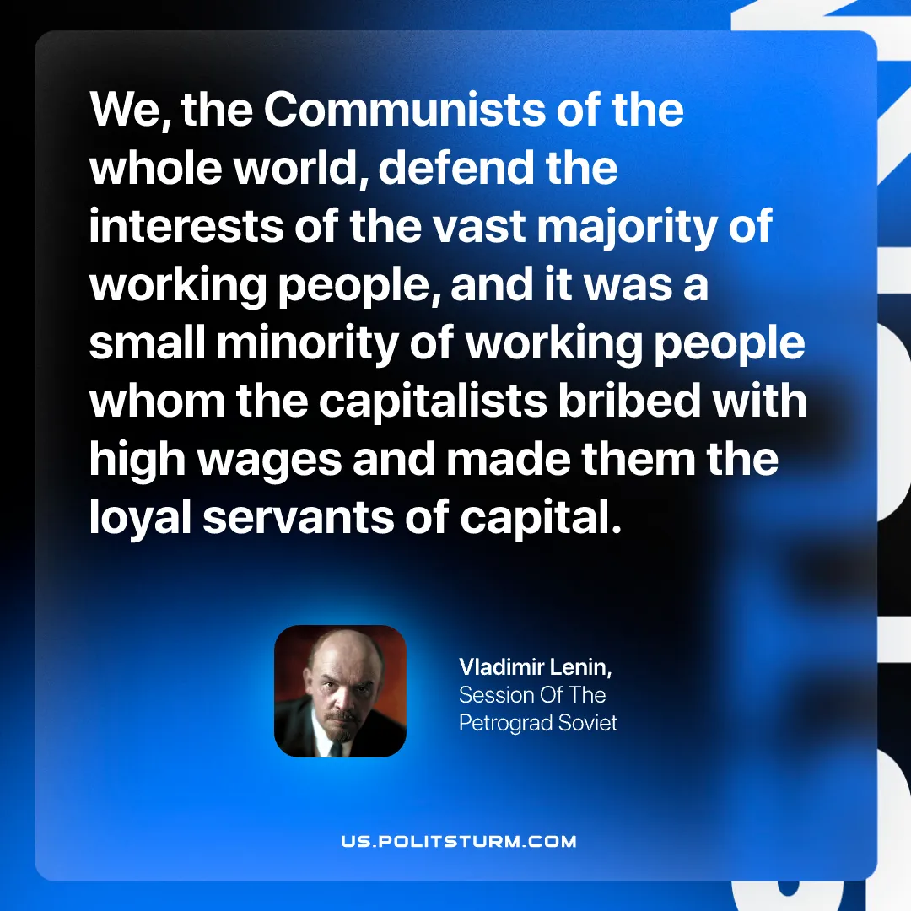

Original article
2026-10-17

We, the Communists of the whole world, defend the interests of the vast majority of working people, and it was a small minority of working people whom the capitalists bribed with high wages and made them the loyal servants of capital.
Vladimir Lenin, Session Of The Petrograd Soviet

Original article

