Lenin on Vigilance after Victory
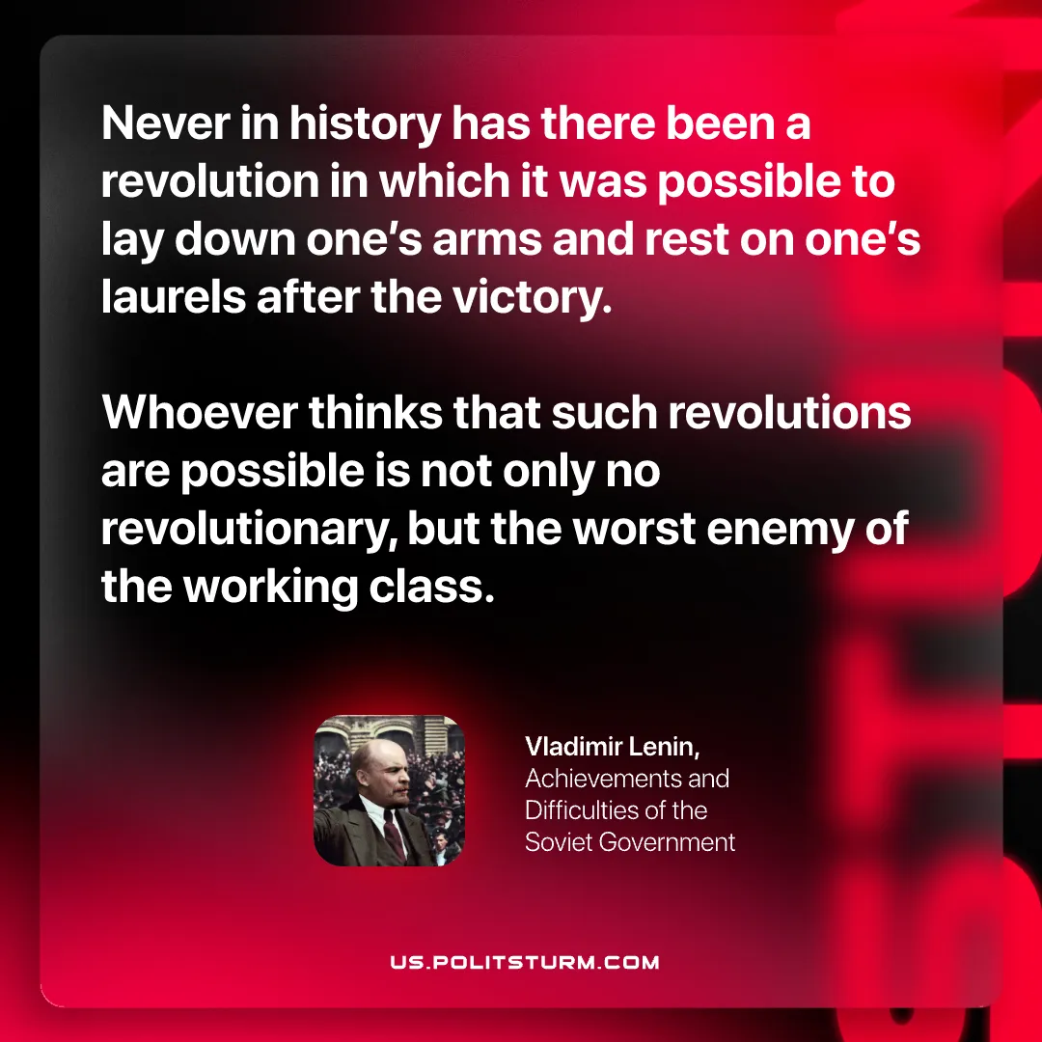

Original article
2026-05-31

Never in history has there been a revolution in which it was possible to lay down one's arms and rest on one's laurels after the victory.
Whoever thinks that such revolutions are possible is not only no revolutionary, but the worst enemy of the working class.
Vladimir Lenin, Achievements and Difficulties of the Soviet Government.

Original article

