Lenin on Victory Over the Capitalists
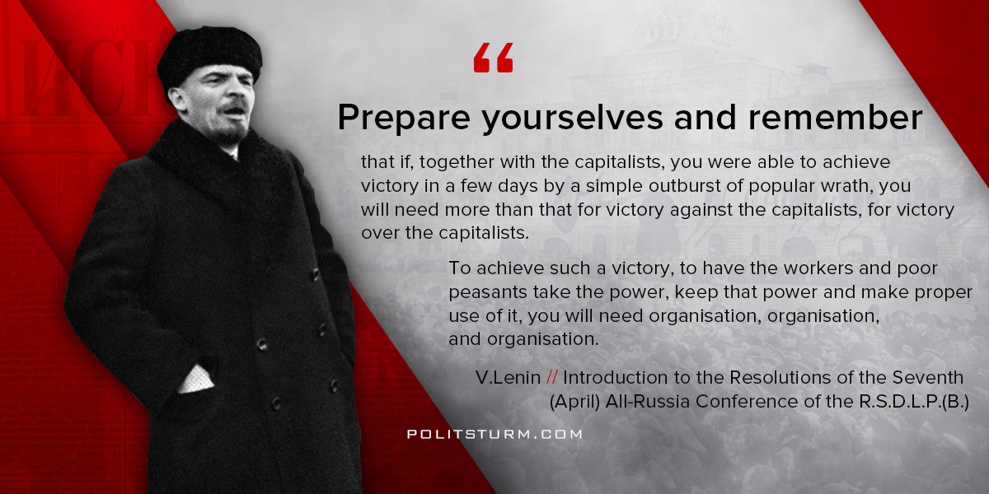

Original article
2018-04-07
1 min read

“Prepare yourselves and remember that if, together with the capitalists, you were able to achieve victory in a few days by a simple outburst of popular wrath, you will need more than that for victory against the capitalists, for victory over the capitalists.
To achieve such a victory, to have the workers and poor peasants take the power, keep that power and make proper use of it, you will need organisation, organisation, and organisation. ”
V.I. Lenin, “Introduction to the Resolutions of the Seventh (April) All-Russia Conference of the R.S.D.L.P.(B.)”

Original article

