Lenin on Unity with Opportunists
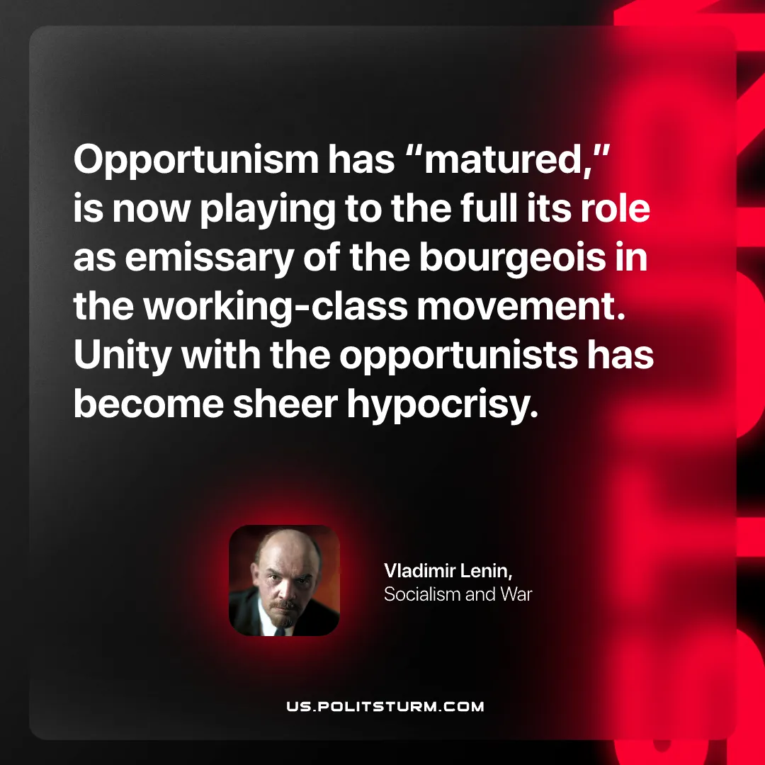

Original article
2026-02-08

“Opportunism has “matured,” is now playing to the full its role as emissary of the bourgeois in the working-class movement. Unity with the opportunists has become sheer hypocrisy…Vladimir Lenin, Socialism and War

Original article

