Lenin on Unity Between Oppressor and Oppressed Nations
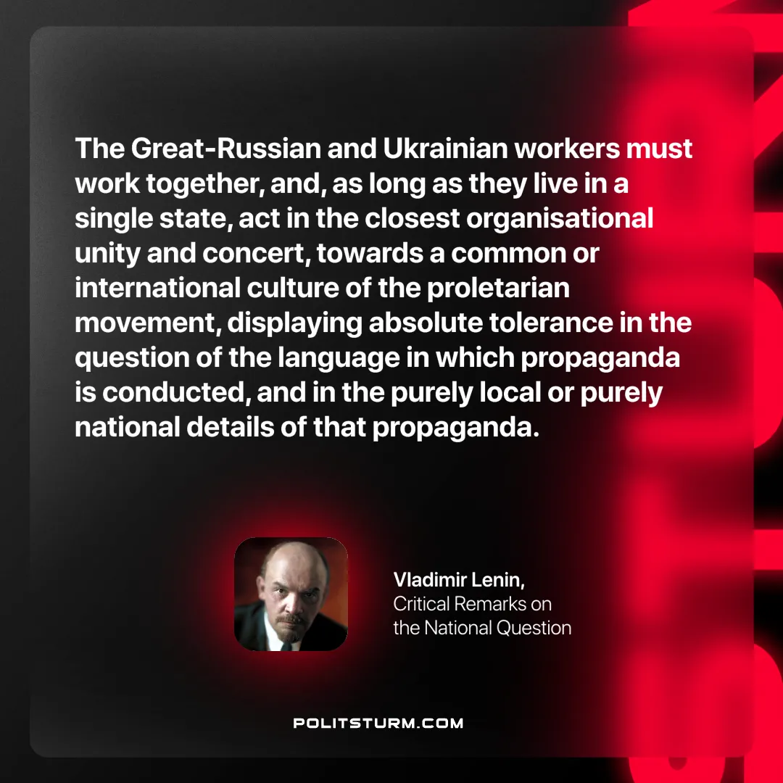

Original article
2024-10-13

“The Great-Russian and Ukrainian workers must work together, and, as long as they live in a single state, act in the closest organisational unity and concert, towards a common or international culture of the proletarian movement, displaying absolute tolerance in the question of the language in which propaganda is conducted, and in the purely local or purely national details of that propaganda.”
Vladimir Lenin, Critical Remarks on the National Question

Original article

