Lenin on Trade Unions
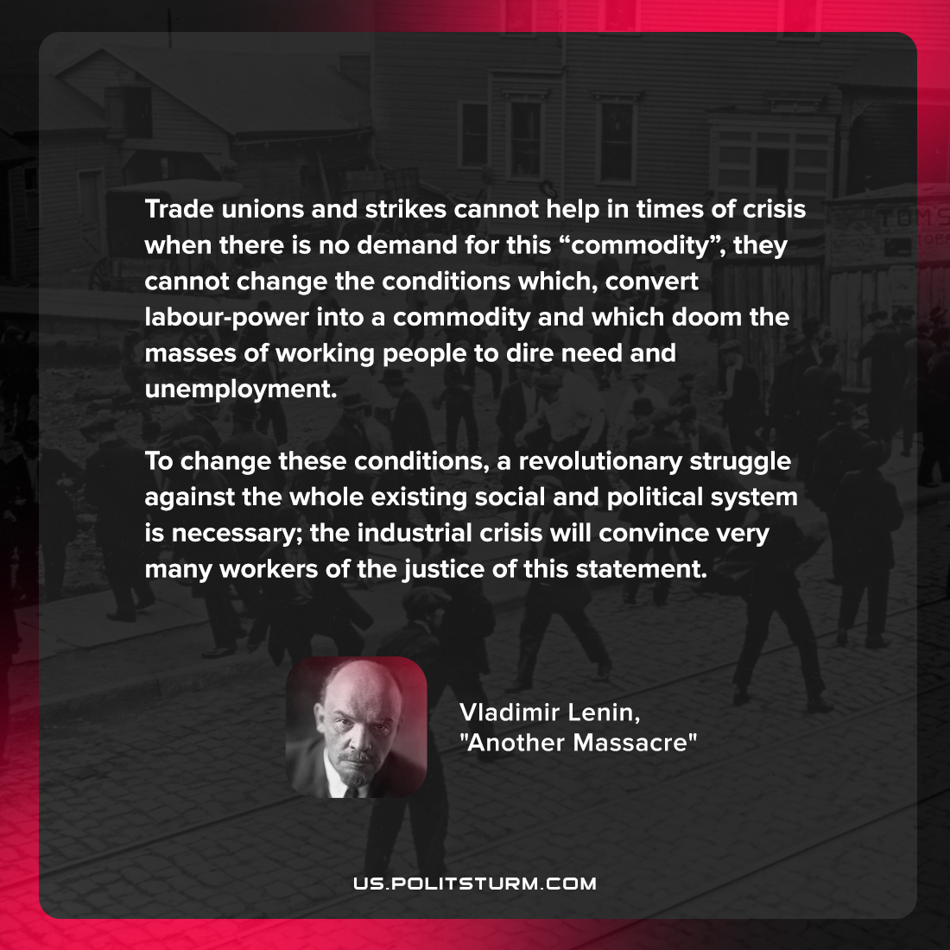

Original article
2022-05-18

Trade unions and strikes cannot help in times of crisis when there is no demand for this “commodity”, they cannot change the conditions which, convert labour-power into a commodity and which doom the masses of working people to dire need and unemployment. To change these conditions, a revolutionary struggle against the whole existing social and political system is necessary; the industrial crisis will convince very many workers of the justice of this statement.

Vladimir Lenin, “Another Massacre”

Original article

