Lenin on the Workers That Follow Opportunists
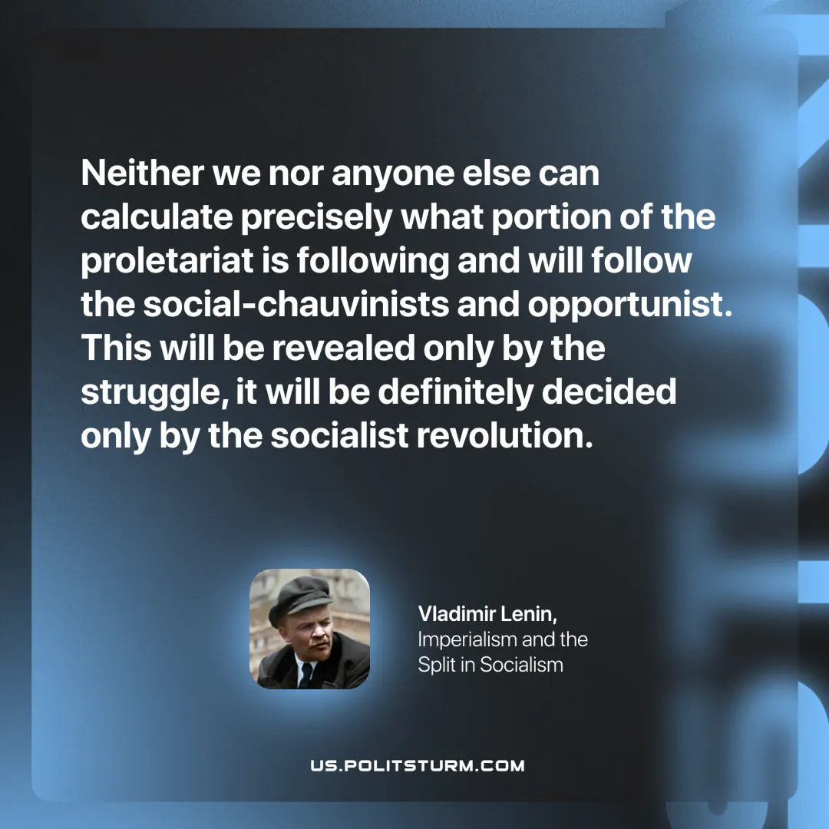

Original article
2025-07-10

“Neither we nor anyone else can calculate precisely what portion of the proletariat is following and will follow the social-chauvinists and opportunists. This will be revealed only by the struggle, it will be definitely decided only by the socialist revolution.”
Vladimir Lenin, Imperialism and the Split in Socialism

Original article

