Lenin on the Withering Away of the State
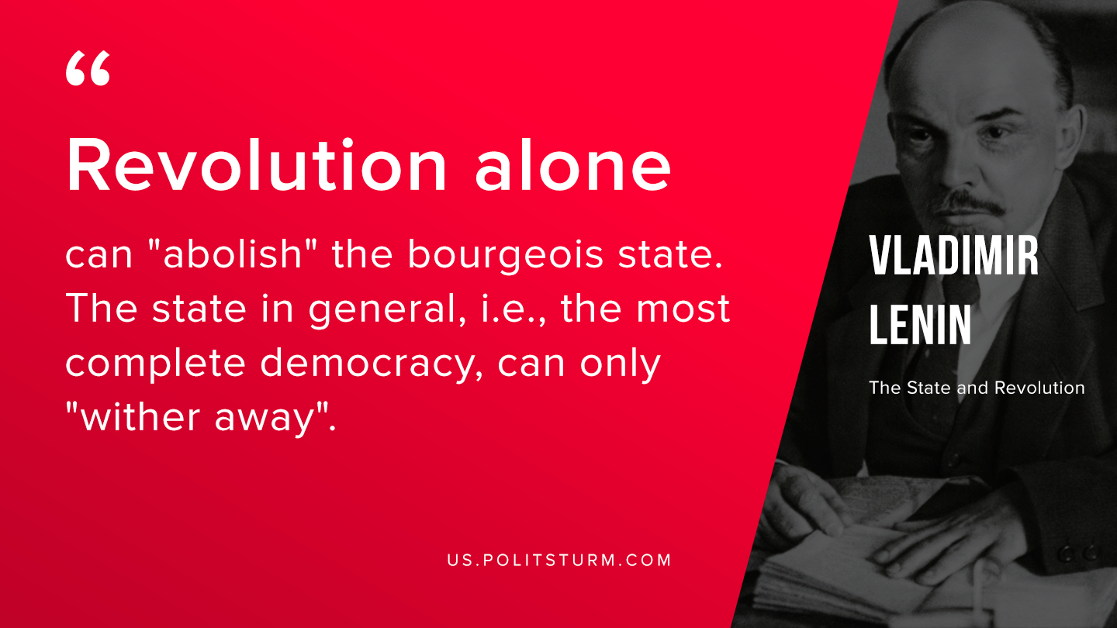

Original article
2019-09-23

Revolution alone can “abolish” the bourgeois state. The state in general, i.e., the most complete democracy, can only “wither away”.
Lenin, “The State and Revolution”

Original article

