Lenin on the Whining Capitalists
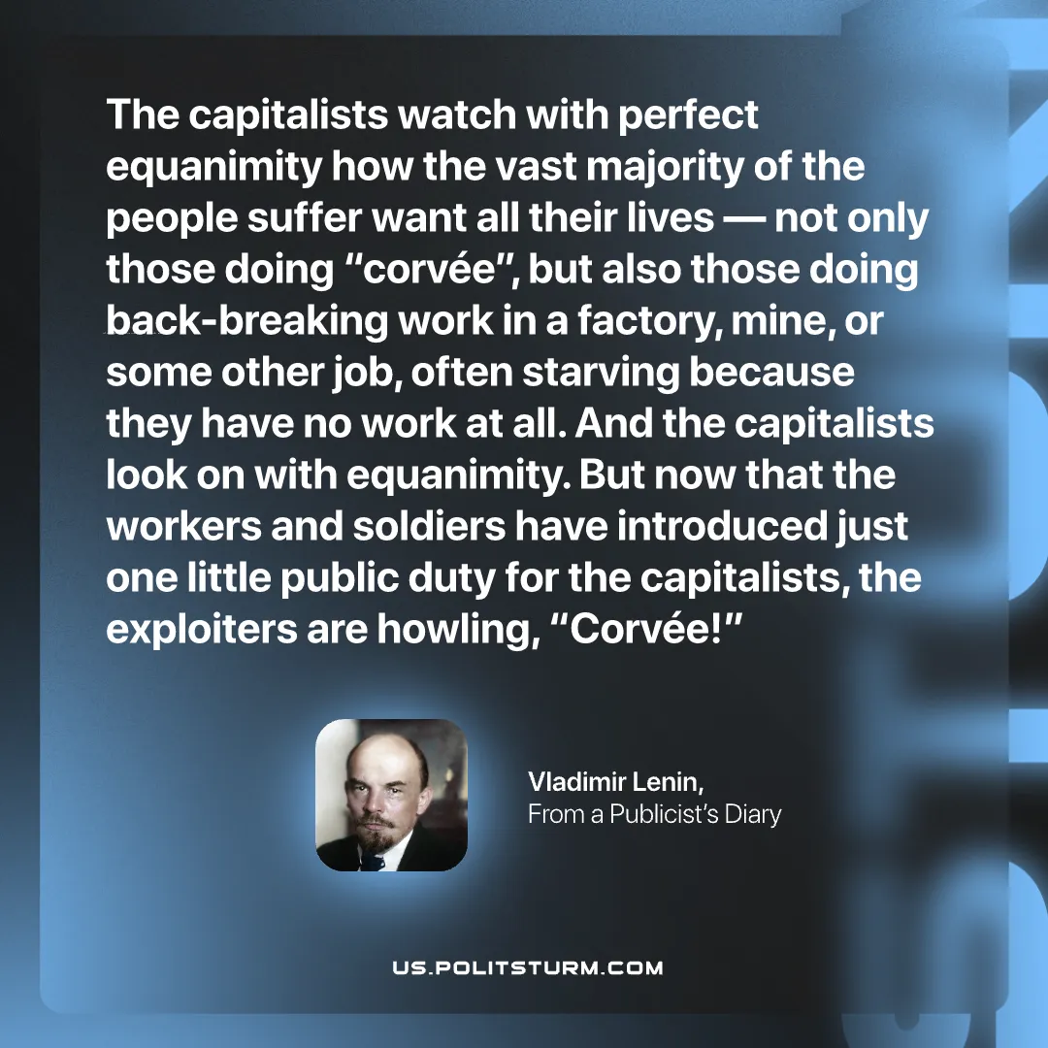

Original article
2026-10-18

The capitalists watch with perfect equanimity how the vast majority of the people suffer want all their lives — not only those doing "corvée", but also those doing back-breaking work in a factory, mine, or some other job, often starving because they have no work at all. And the capitalists look on with equanimity. But now that the workers and soldiers have introduced just one little public duty for the capitalists, the exploiters are howling, "Corvée!"
Vladimir Lenin, From a Publicist's Diary

Original article

