Lenin on the War and Revolution of the Working Class
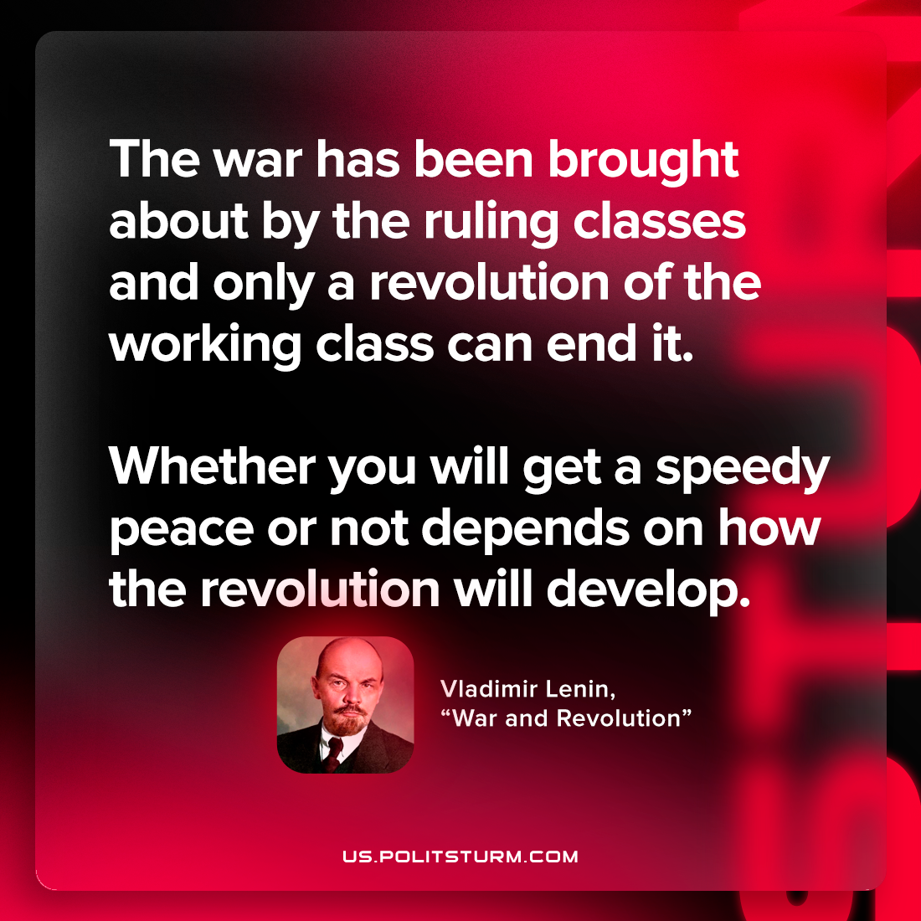

Original article
2023-02-25

"The war has been brought about by the ruling classes and only a revolution of the working class can end it. Whether you will get a speedy peace or not depends on how the revolution will develop."
Vladimir Lenin, “War and Revolution”

Original article

