Lenin on the Usage of Violence and Suppression by the Capitalists Against the Workers
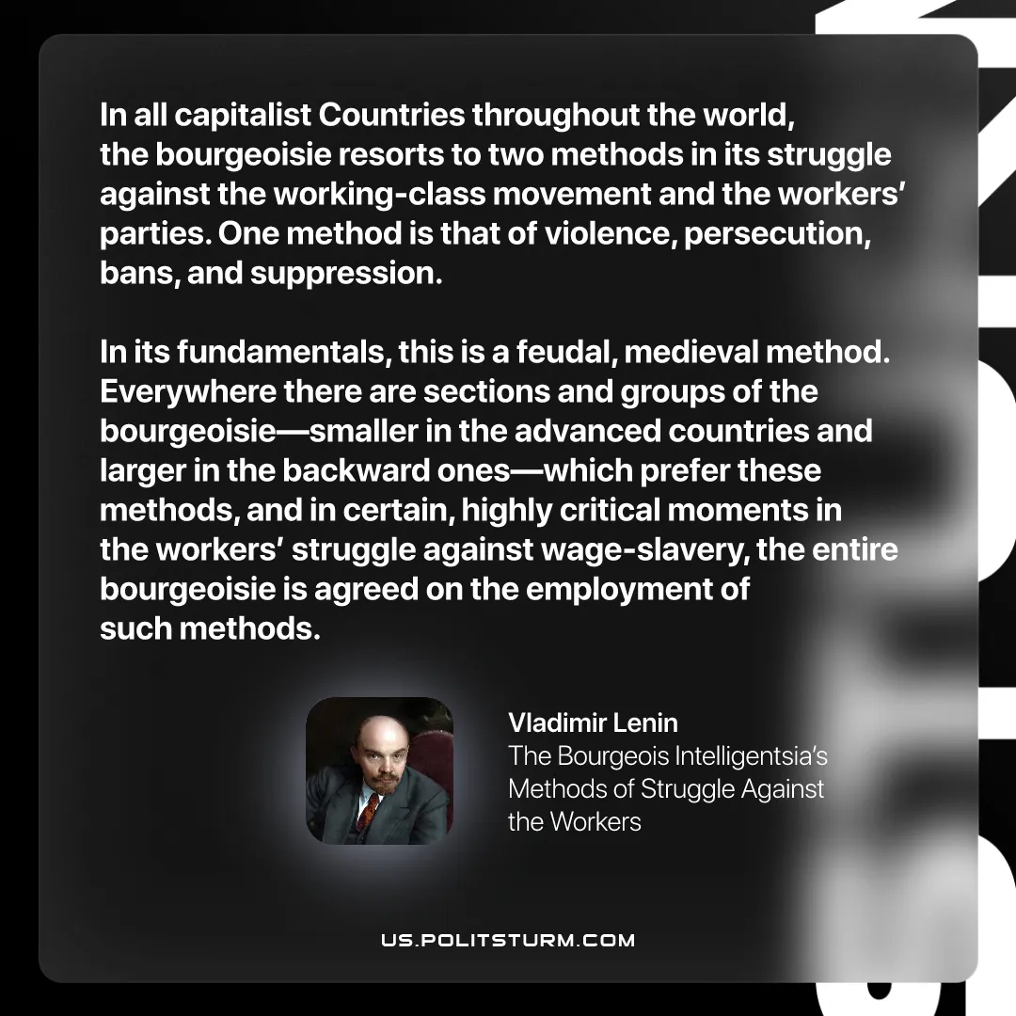

Original article
2026-01-24
1 min read

“In all capitalist Countries throughout the world, the bourgeoisie resorts to two methods in its struggle against the working-class movement and the workers’ parties. One method is that of violence, persecution, bans, and suppression. In its fundamentals, this is a feudal, medieval method. Everywhere there are sections and groups of the bourgeoisie—smaller in the advanced countries and larger in the backward ones—which prefer these methods, and in certain, highly critical moments in the workers’ struggle against wage-slavery, the entire bourgeoisie is agreed on the employment of such methods.”
Vladimir Lenin, The Bourgeois Intelligentsia’s Methods of Struggle Against the Workers

Original article

