Lenin on the Unity of the Proletariat
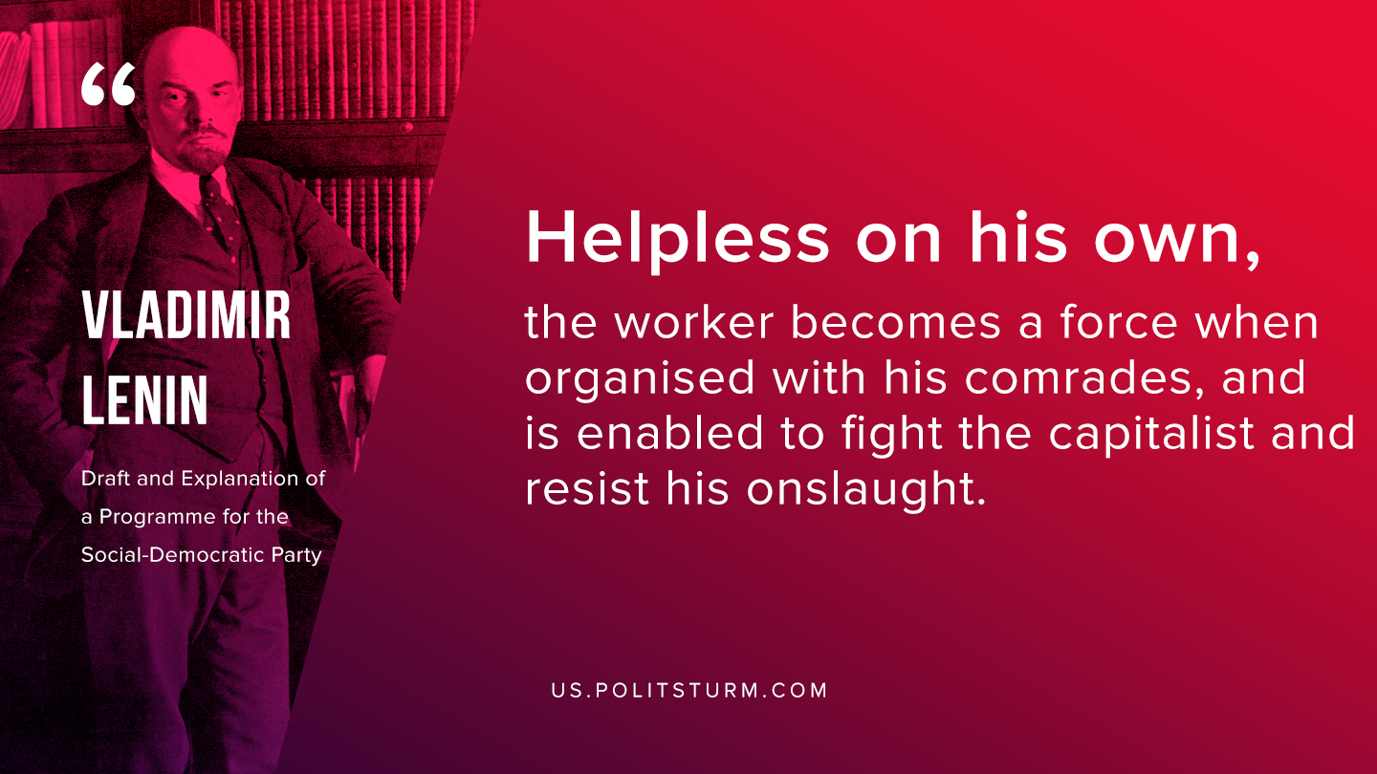

Original article
2019-11-12

Helpless on his own, the worker becomes a force when organised with his comrades, and is enabled to fight the capitalist and resist his onslaught.
V.I. Lenin “Draft and Explanation of a Programme for the Social-Democratic Party”

Original article

