Lenin on the Temporary Interests of Opportunism
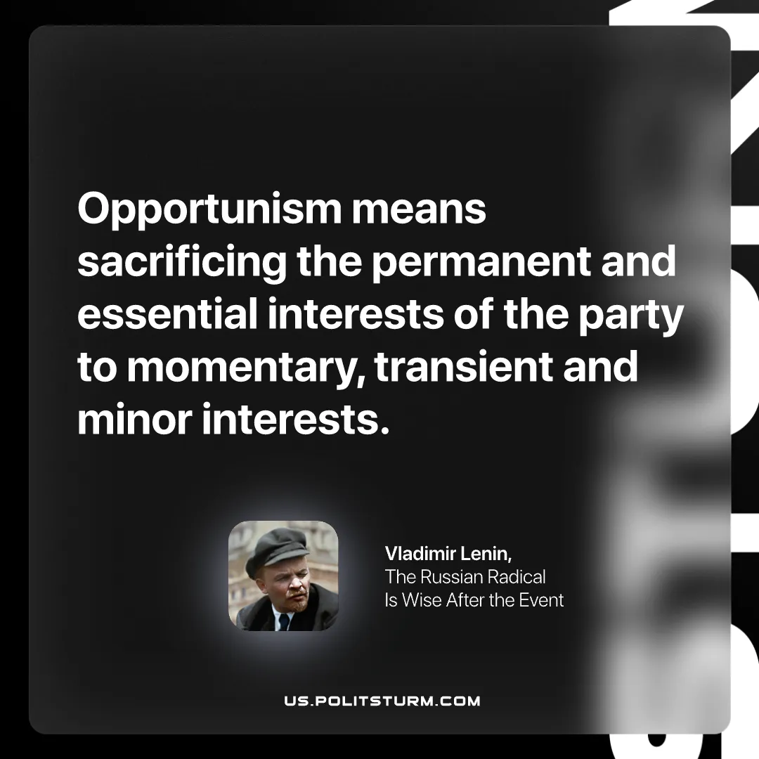

Original article
2025-12-30

“Opportunism means sacrificing the permanent and essential interests of the party to momentary, transient and minor interests.”
Vladimir. Lenin, The Russian Radical Is Wise After the Event

Original article

