Lenin on the Task of Uniting the Workers of Oppressed and Oppressor Nations
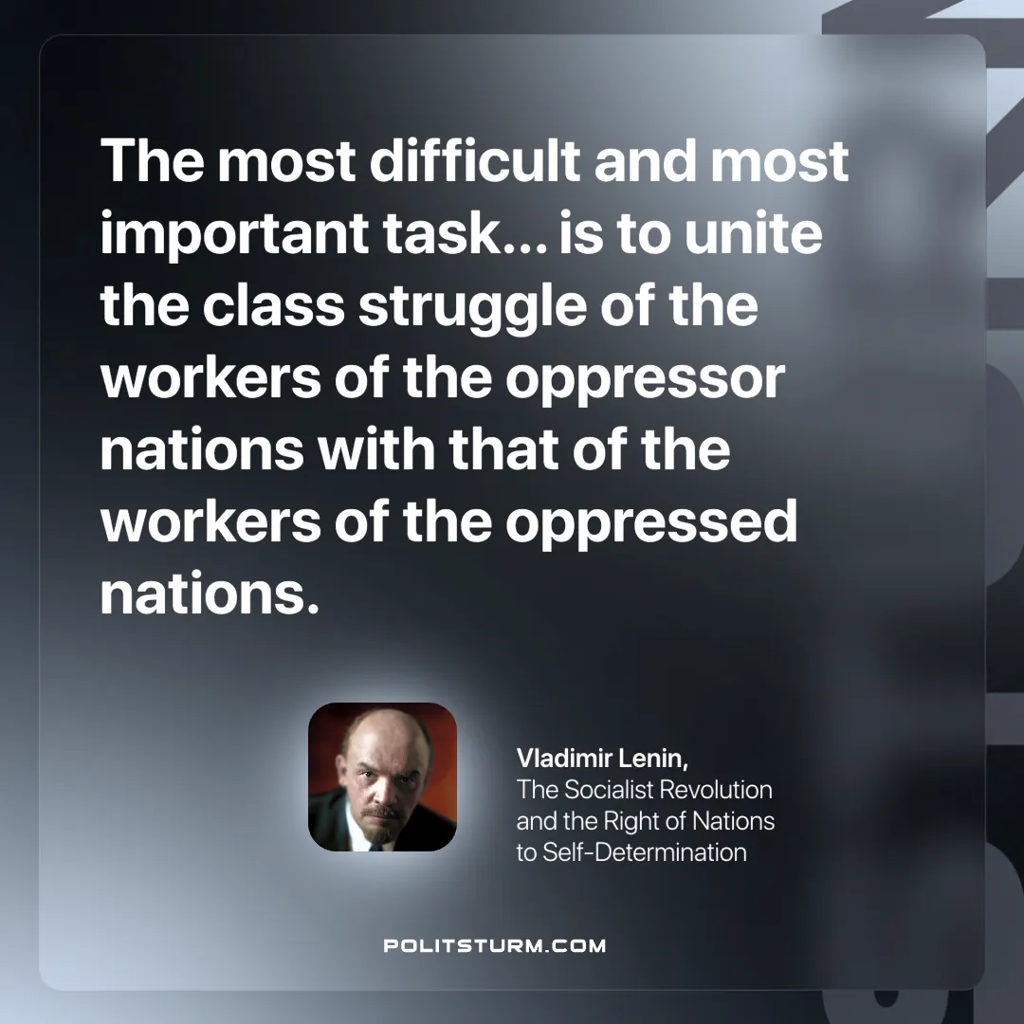

Original article
2025-05-29

“The most difficult and most important task… is to unite the class struggle of the workers of the oppressor nations with that of the workers of the oppressed nations.”
Vladimir Lenin, The Socialist Revolution and the Right of Nations to Self-Determination

Original article

