Lenin on the Successful Struggle Against Exploitation
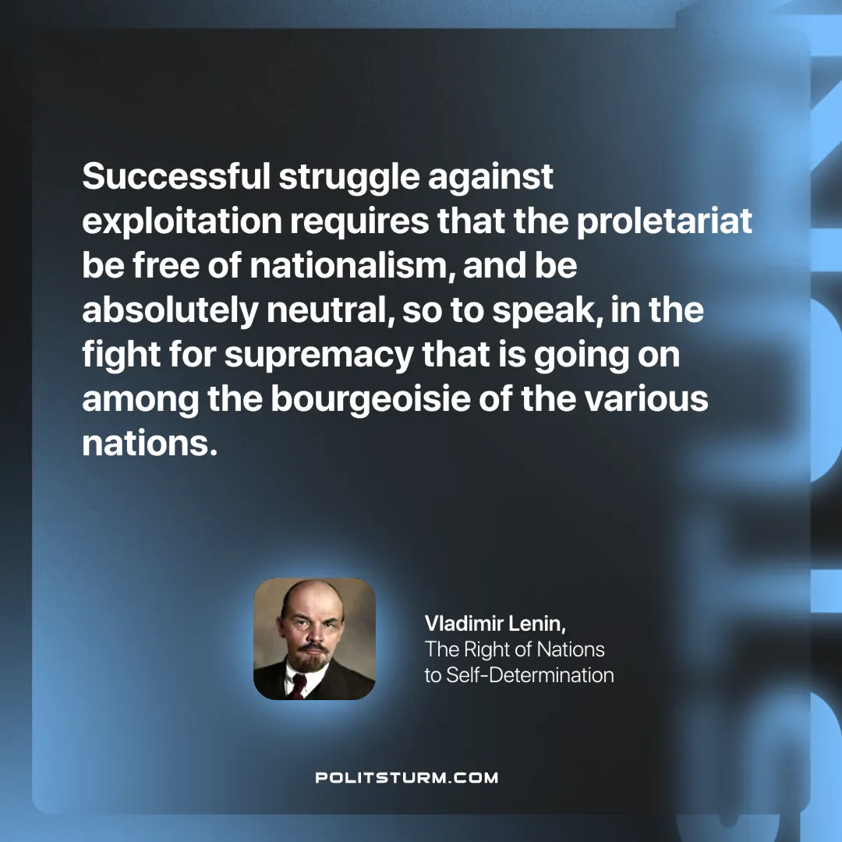

Original article
2024-10-05

“Successful struggle against exploitation requires that the proletariat be free of nationalism, and be absolutely neutral, so to speak, in the fight for supremacy that is going on among the bourgeoisie of the various nations.”
Vladimir Lenin, The Right of Nations to Self-Determination

Original article

