Lenin on the Success of the Bolsheviks in Discipline and Support
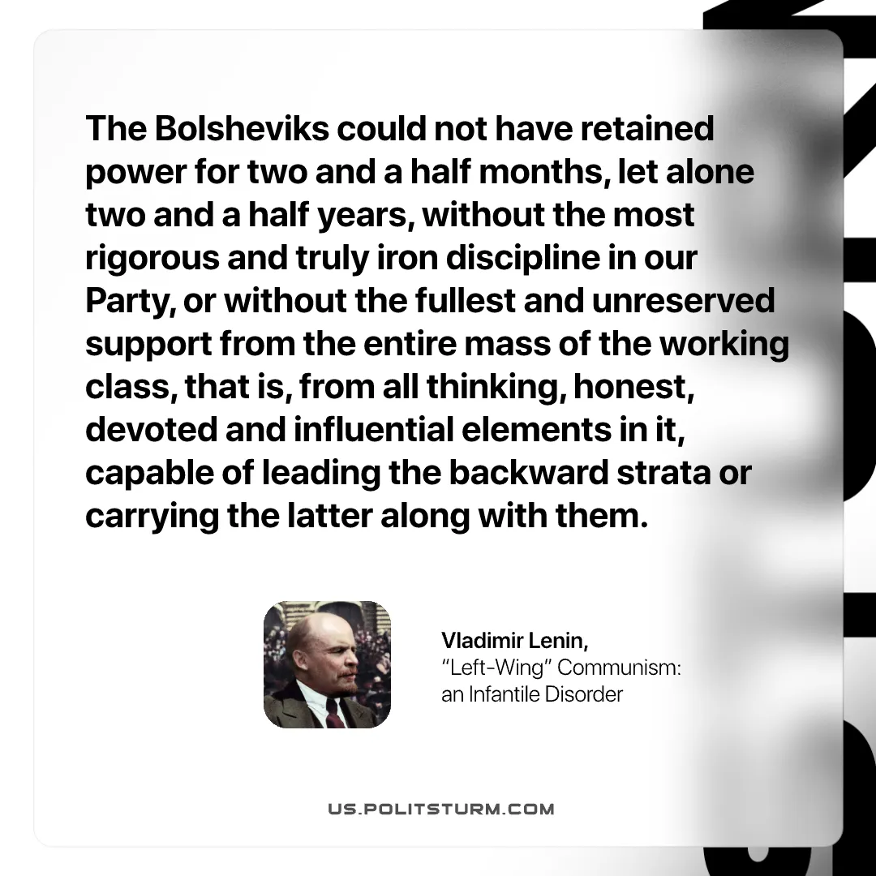

Original article
2025-12-21

The Bolsheviks could not have retained power for two and a half months, let alone two and a half years, without the most rigorous and truly iron discipline in our Party, or without the fullest and unreserved support from the entire mass of the working class, that is, from all thinking, honest, devoted and influential elements in it, capable of leading the backward strata or carrying the latter along with them.
Vladimir Lenin, “Left-Wing” Communism: an Infantile Disorder

Original article

