Lenin on the Substance of War
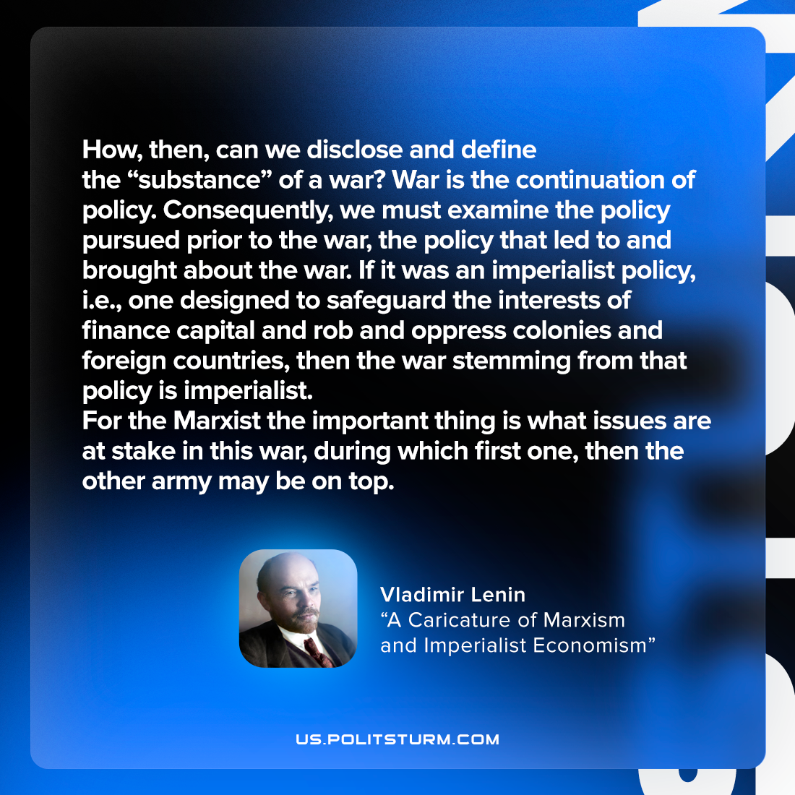

Original article
2022-06-22
1 min read

How, then, can we disclose and define the “substance” of a war? War is the continuation of policy. Consequently, we must examine the policy pursued prior to the war, the policy that led to and brought about the war. If it was an imperialist policy,
i.e., one designed to safeguard the interests of finance capital and rob and oppress colonies and foreign countries, then the war stemming from that policy is imperialist.
For the Marxist the important thing is what issues are at stake in this war, during which first one, then the other army may be on top.

Original article

