Lenin on the Struggle of the Proletariat
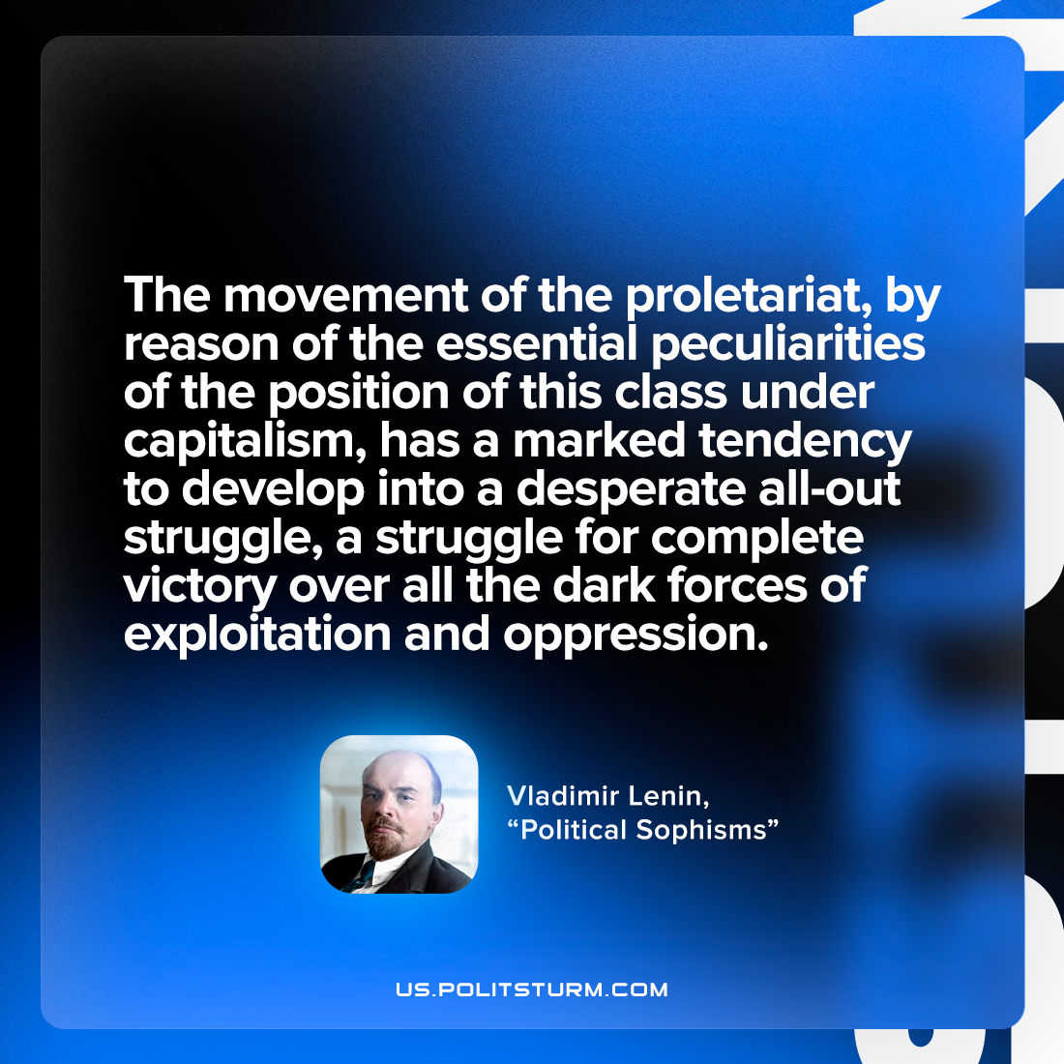

Original article
2022-10-10

The movement of the proletariat, by reason of the essential peculiarities of the position of this class under capitalism, has a marked tendency to develop into a desperate all-out struggle, a struggle for complete victory over all the dark forces of exploitation and oppression.

Vladimir Lenin, “Political Sophisms”

Original article

