Lenin on the Struggle of Proletariat
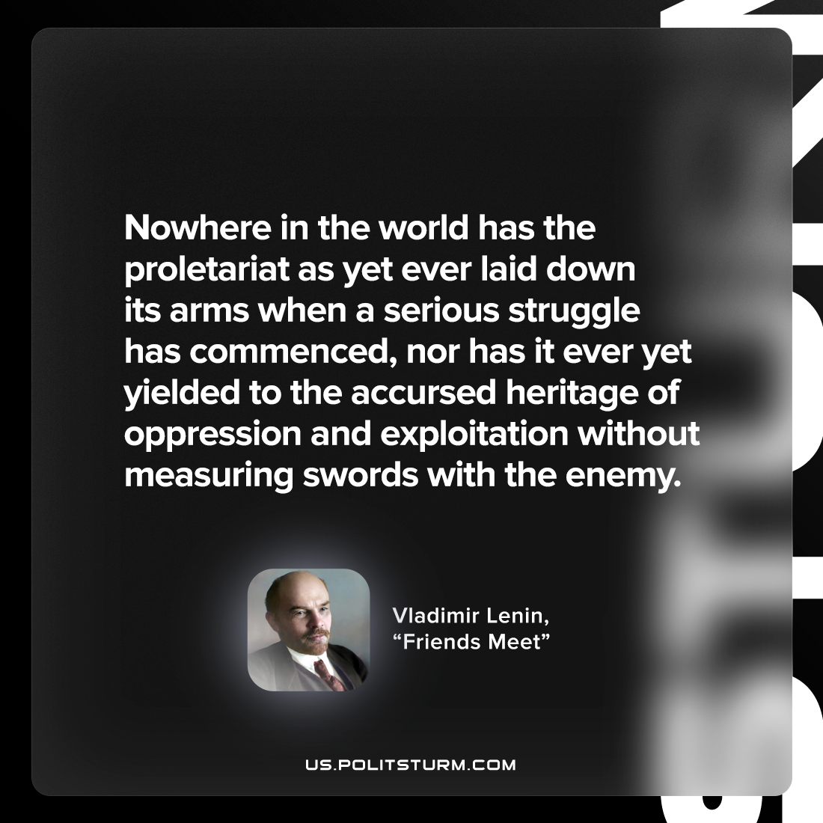

Original article
2022-10-24

Nowhere in the world has the proletariat as yet ever laid down its arms when a serious struggle has commenced, nor has it ever yet yielded to the accursed heritage of oppression and exploitation without measuring swords with the enemy.

Vladimir Lenin, “Friends Meet”

Original article

