Lenin on the Struggle as Education
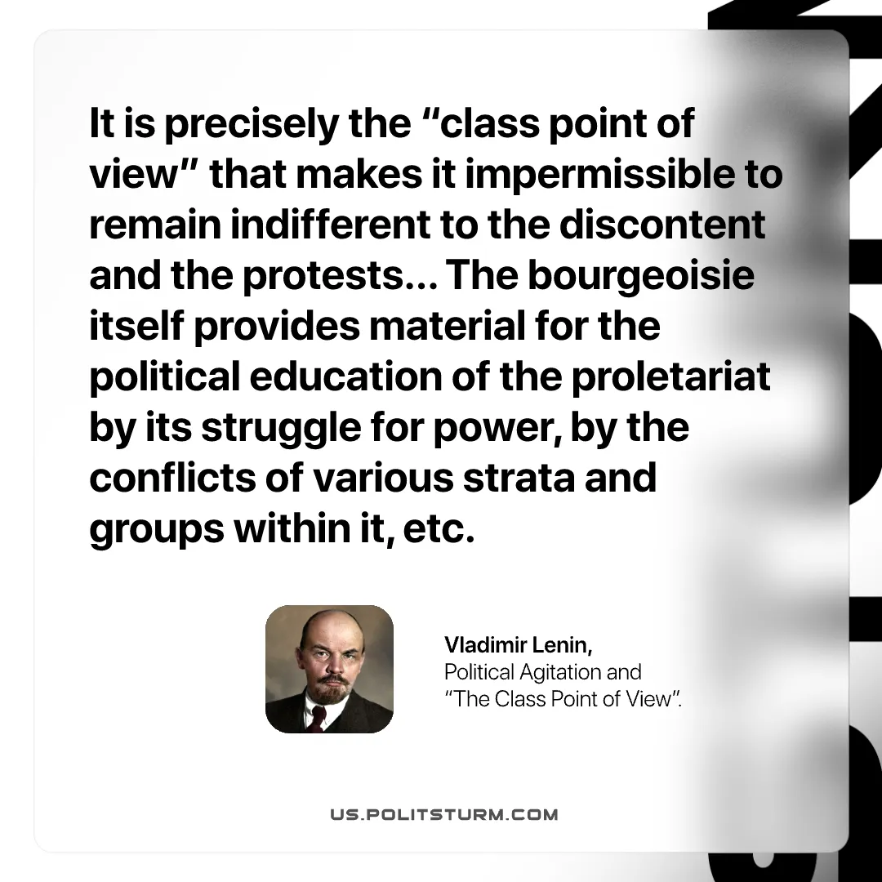

Original article
2026-06-23

It is precisely the "class point of view" that makes it impermissible to remain indifferent to the discontent and the protests… The bourgeoisie itself provides material for the political education of the proletariat by its struggle for power, by the conflicts of various strata and groups within it, etc.
Vladimir Lenin, Political Agitation and "The Class Point of View".

Original article

