Lenin on the struggle against opportunism
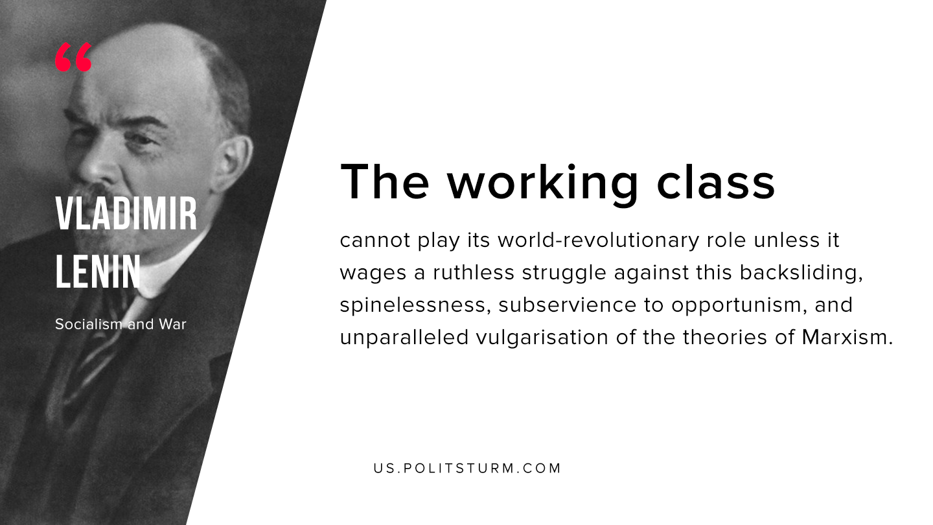

Original article
2019-12-21

The working class cannot play its world-revolutionary role unless it wages a ruthless struggle against this backsliding, spinelessness, subservience to opportunism, and unparalleled vulgarisation of the theories of Marxism.
V.I. Lenin “Socialism and War”

Original article

