Lenin on the Strength
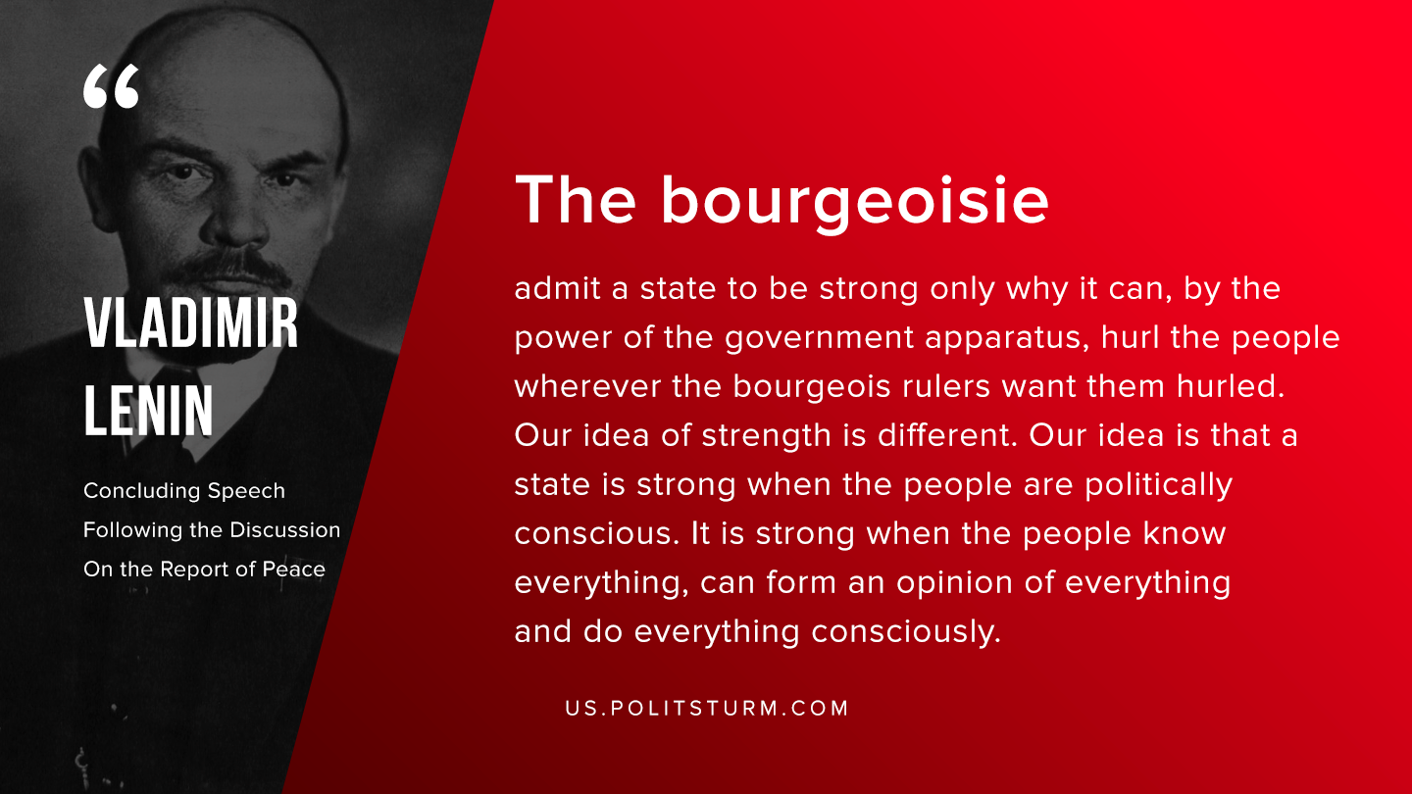

Original article
2019-09-18

The bourgeoisie admit a state to be strong only why it can, by the power of the government apparatus, hurl the people wherever the bourgeois rulers want them hurled. Our idea of strength is different. Our idea is that a state is strong when the people are politically conscious. It is strong when the people know everything, can form an opinion of everything and do everything consciously.
Vladimir Lenin, “Concluding Speech Following the Discussion On the Report of Peace”

Original article

