Lenin on the Strength of the Workers in Organization
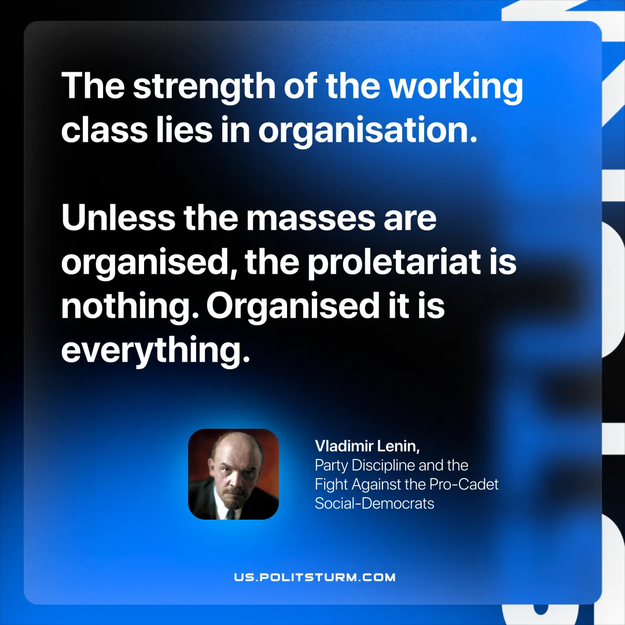

Original article
2025-11-30

“The strength of the working class lies in organisation. Unless the masses are organised, the proletariat is nothing. Organised—it is everything.”
Vladimir Lenin, Party Discipline and the Fight Against the Pro-Cadet Social-Democrats

Original article

