Lenin on The State
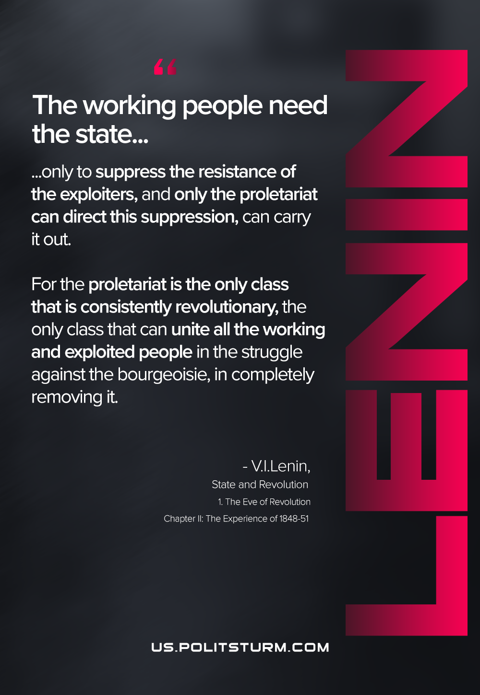

Original article
2020-12-12

The working people need the state only to suppress the resistance of the exploiters, and only the proletariat can direct this suppression, can carry it out. For the proletariat is the only class that is consistently revolutionary, the only class that can unite all the working and exploited people in the struggle against the bourgeoisie, in completely removing it.
Vladimir Lenin, The State and Revolution

Original article

