Lenin on the State and Class Antagonism
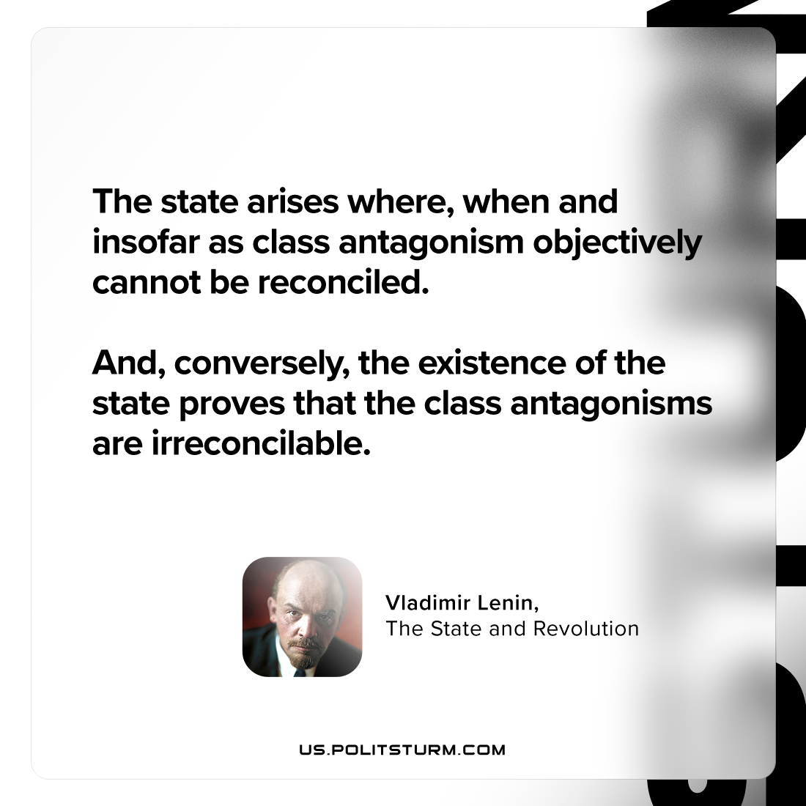

Original article
2024-01-13

"The state arises where, when and insofar as class antagonism objectively cannot be reconciled. And, conversely, the existence of the state proves that the class antagonisms are irreconcilable."
Vladimir Lenin, The State and Revolution

Original article

