Lenin on the Socialist State
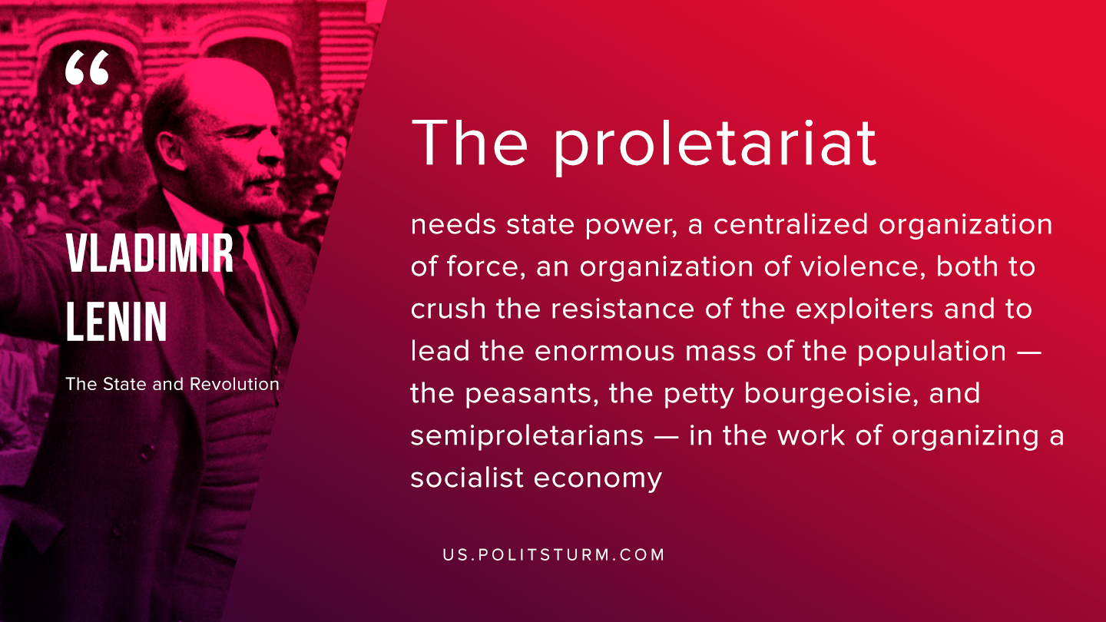

Original article
2019-09-27

The proletariat needs state power, a centralized organization of force, an organization of violence, both to crush the resistance of the exploiters and to lead the enormous mass of the population – the peasants, the petty bourgeoisie, and semiproletarians – in the work of organizing a socialist economy.
Vladimir Lenin, “The State and Revolution”

Original article

