Lenin on the Signs of Opportunism
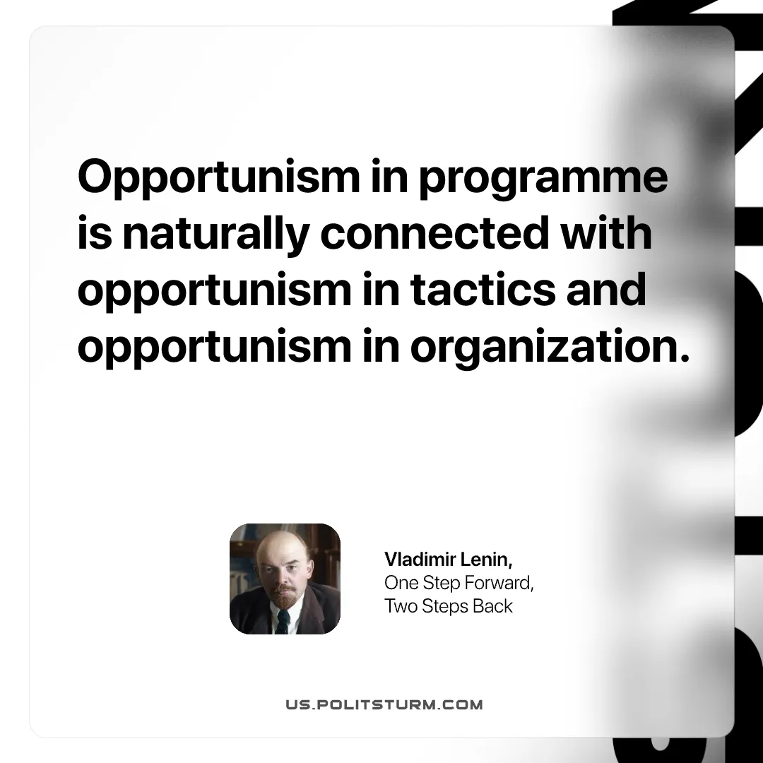

Original article
2026-08-08

Opportunism in programme is naturally connected with opportunism in tactics and opportunism in organization.
Vladimir Lenin, One Step Forward, Two Steps Back

Original article

