Lenin on the Separation of Opportunism From Communism
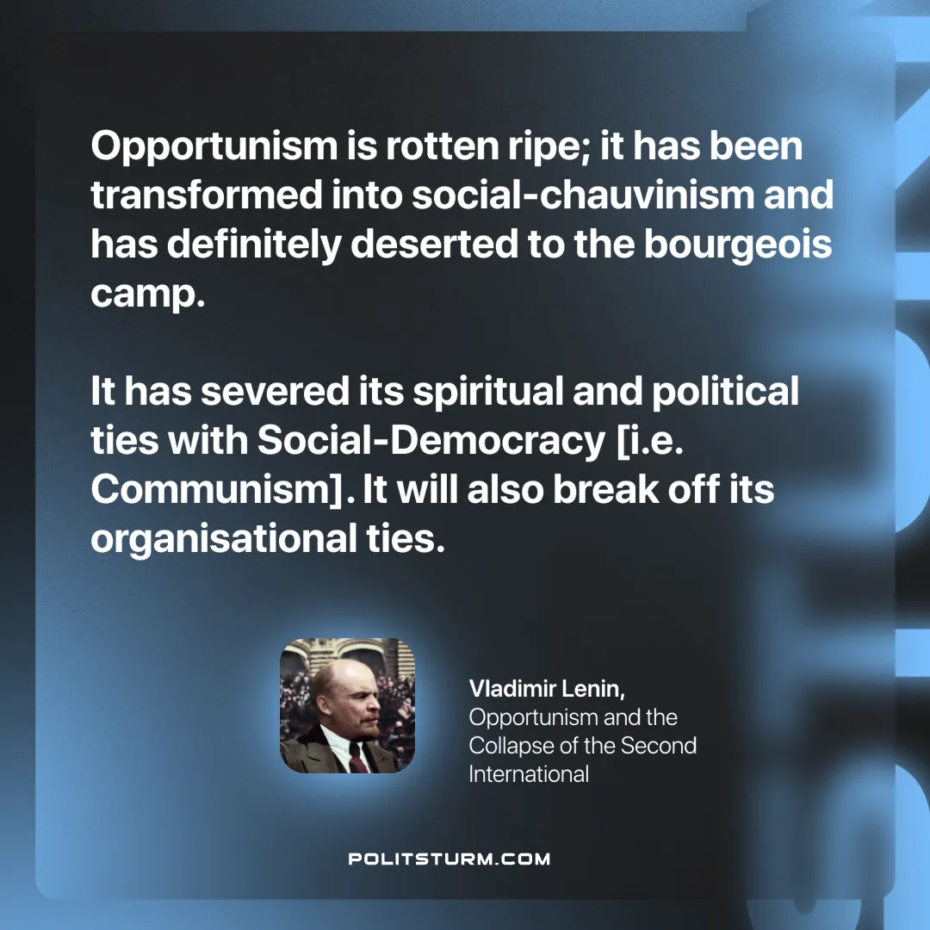

Original article
2025-06-03

“Opportunism is rotten ripe; it has been transformed into social-chauvinism and has definitely deserted to the bourgeois camp. It has severed its spiritual and political ties with Social-Democracy. It will also break off its organisational ties.”
Vladimir Lenin, Opportunism and the Collapse of the Second International

Original article

