Lenin on the Separation of Church and State
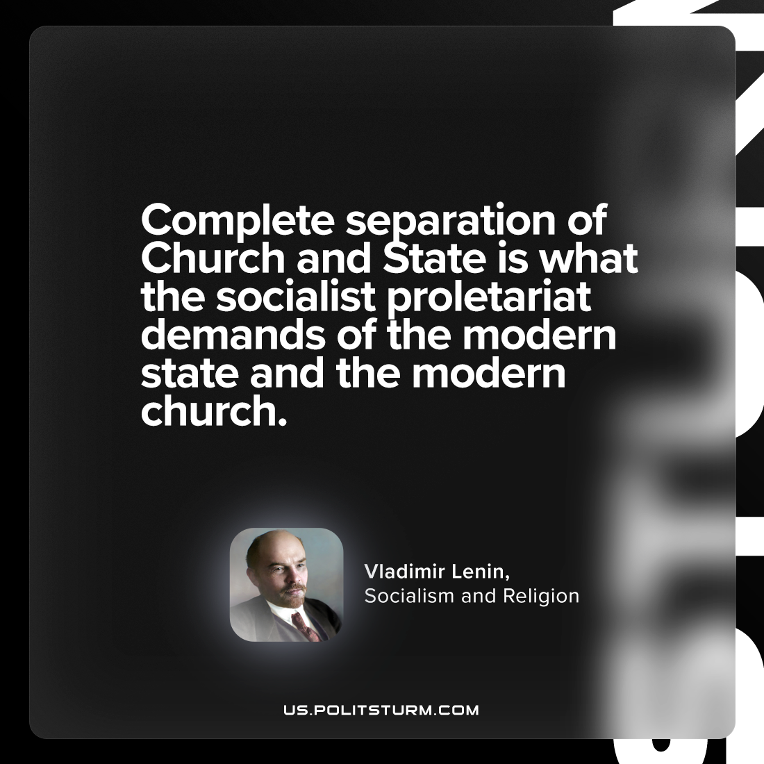

Original article
2024-03-19

“Complete separation of Church and State is what the socialist proletariat demands of the modern state and the modern church.”
Vladimir Lenin, Socialism and Religion

Original article

