Lenin on the Roots of War
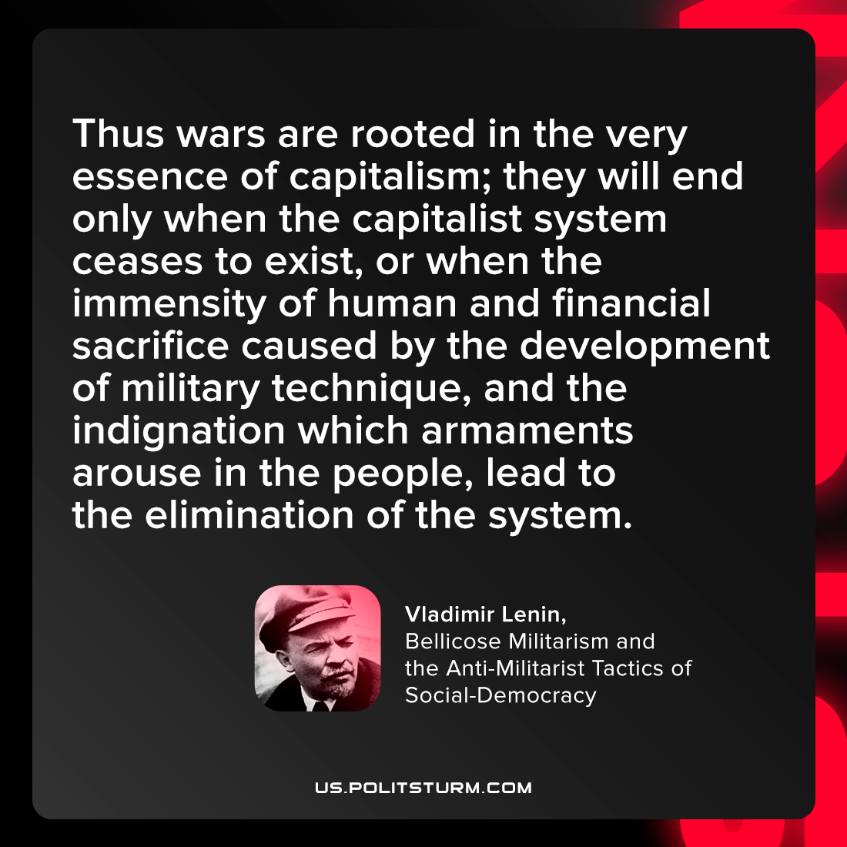

Original article
2022-03-09

Thus wars are rooted in the very essence of capitalism; they will end only when the capitalist system ceases to exist, or when the immensity of human and financial sacrifice caused by the development of military technique, and the indignation which armaments arouse in the people, lead to the elimination of the system.

Vladimir Lenin, “Bellicose Militarism and the Anti-Militarist Tactics of Social-Democracy”

Original article

