Lenin on the Roots of Religion Today
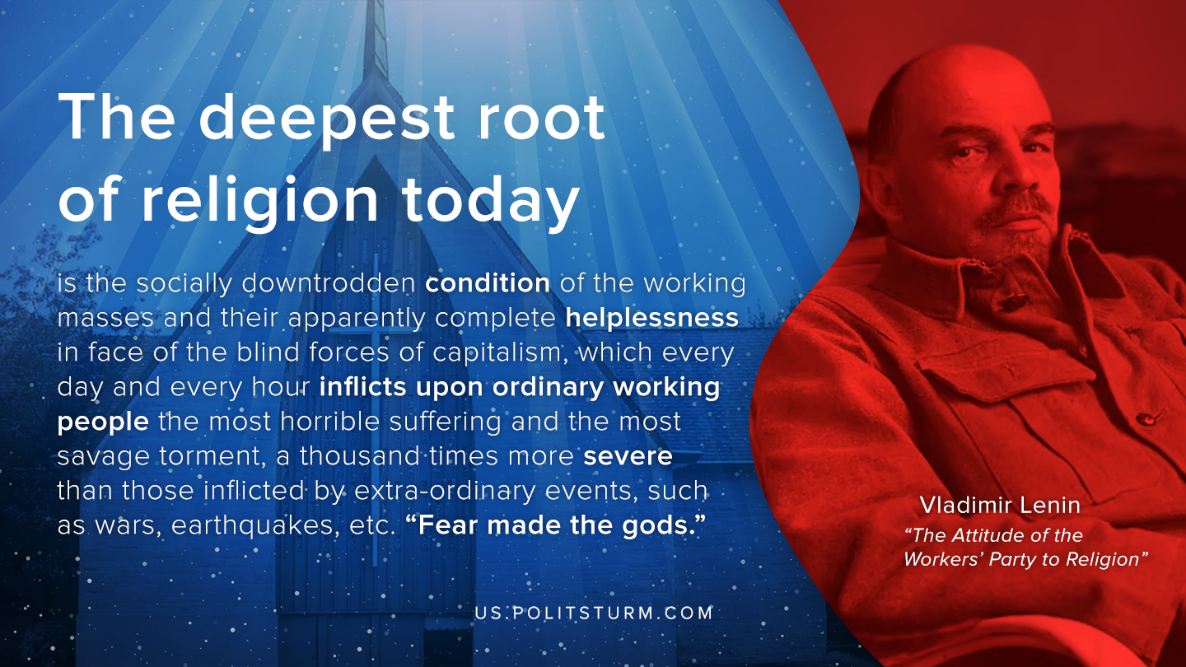

Original article
2020-06-26

The deepest root of religion today is the socially downtrodden condition of the working masses and their apparently complete helplessness in face of the blind forces of capitalism, which every day and every hour inflicts upon ordinary working people the most horrible suffering and the most savage torment, a thousand times more severe than those inflicted by extra-ordinary events, such as wars, earthquakes, etc. “Fear made the gods.”
Vladimir Ilyich Lenin, The Attitude of the Workers’ Party to Religion

Original article

