Lenin on the Role of the Proletariat in the National Question
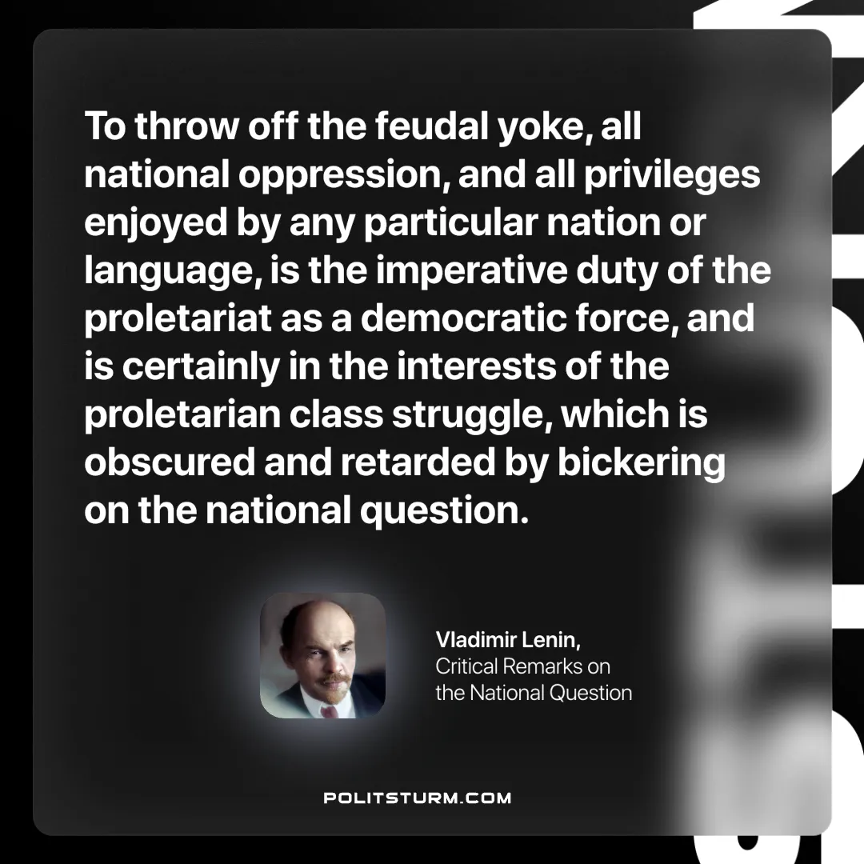

Original article
2025-01-04

“To throw off the feudal yoke, all national oppression, and all privileges enjoyed by any particular nation or language, is the imperative duty of the proletariat as a democratic force, and is certainly in the interests of the proletarian class struggle, which is obscured and retarded by bickering on the national question.”
Vladimir Lenin, Critical Remarks on the National Question

Original article

