Lenin on the Role of the Oppressed Nation Maintaining Unity
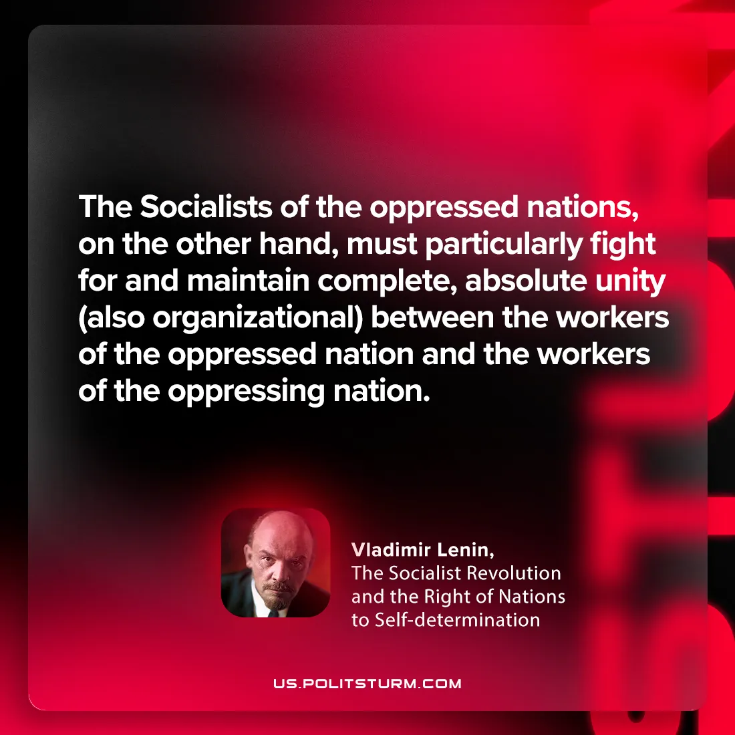

Original article
2024-09-21

“The Socialists of the oppressed nations, on the other hand, must particularly fight for and maintain complete, absolute unity (also organizational) between the workers of the oppressed nation and the workers of the oppressing nation.”
Vladimir Lenin, The Socialist Revolution and the Right of Nations to Self-determination

Original article

