Lenin on the Role of the Bourgeoisie Government
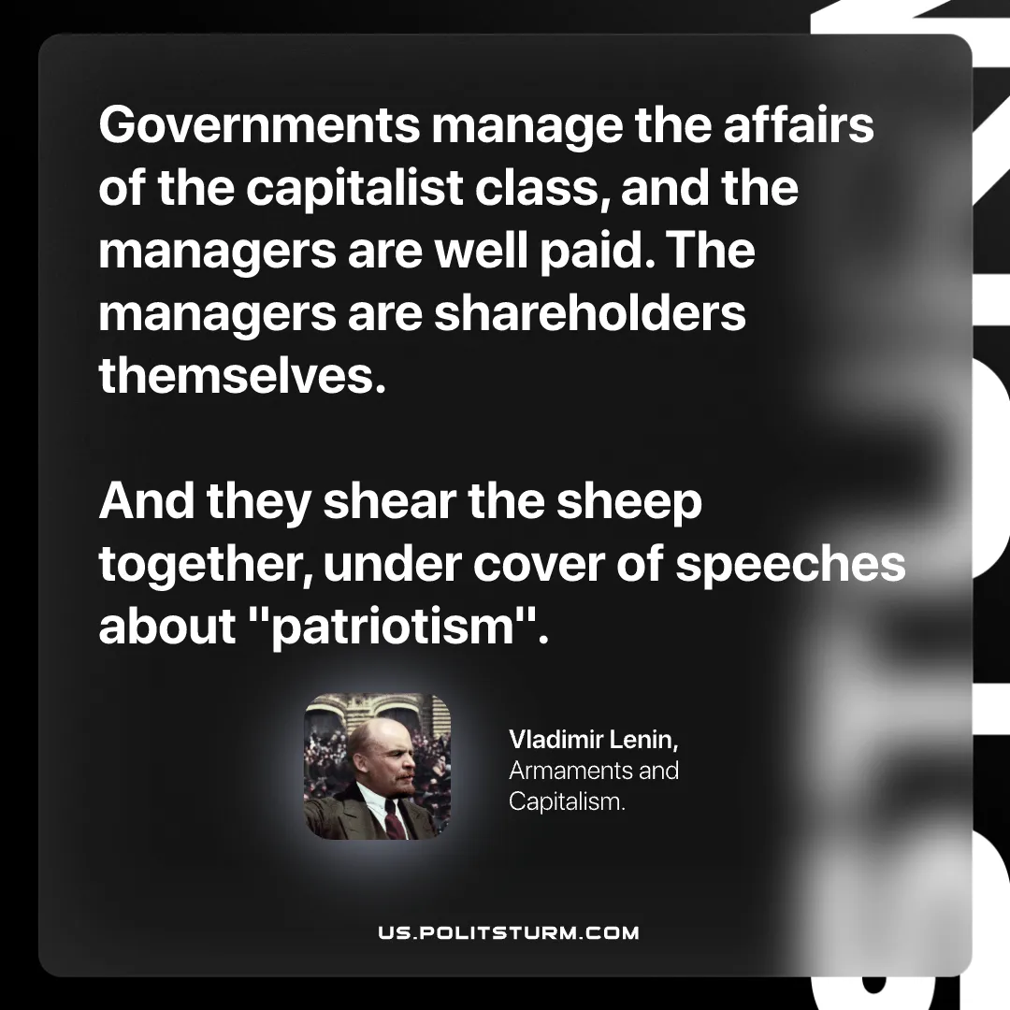

Original article
2026-07-23

Governments manage the affairs of the capitalist class, and the managers are well paid. The managers are shareholders themselves.
And they shear the sheep together, under cover of speeches about "patriotism".
Vladimir Lenin, Armaments and Capitalism

Original article

