Lenin on the Role of Small Nations
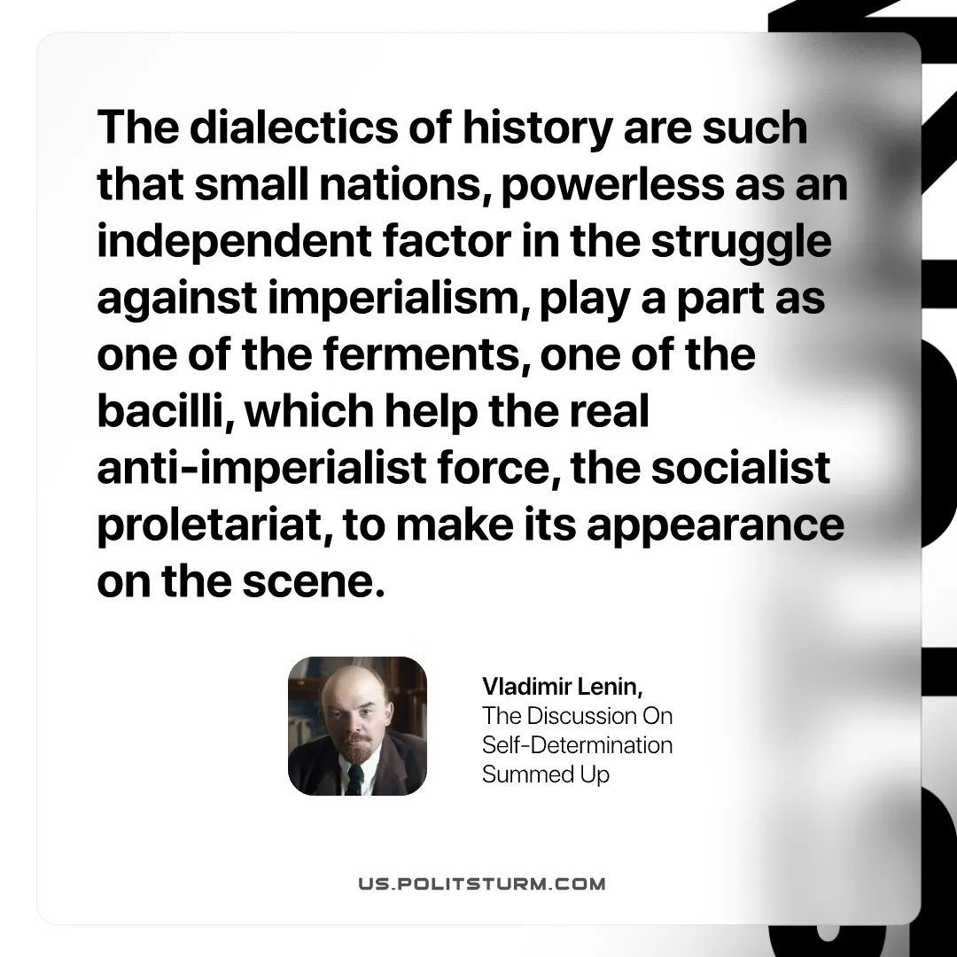

Original article
2026-10-25

The dialectics of history are such that small nations, powerless as an independent factor in the struggle against imperialism, play a part as one of the ferments, one of the bacilli, which help the real anti-imperialist force, the socialist proletariat, to make its appearance on the scene.
Vladimir Lenin, The Discussion On Self-Determination Summed Up

Original article

