Lenin on the Revolutionary Vanguard
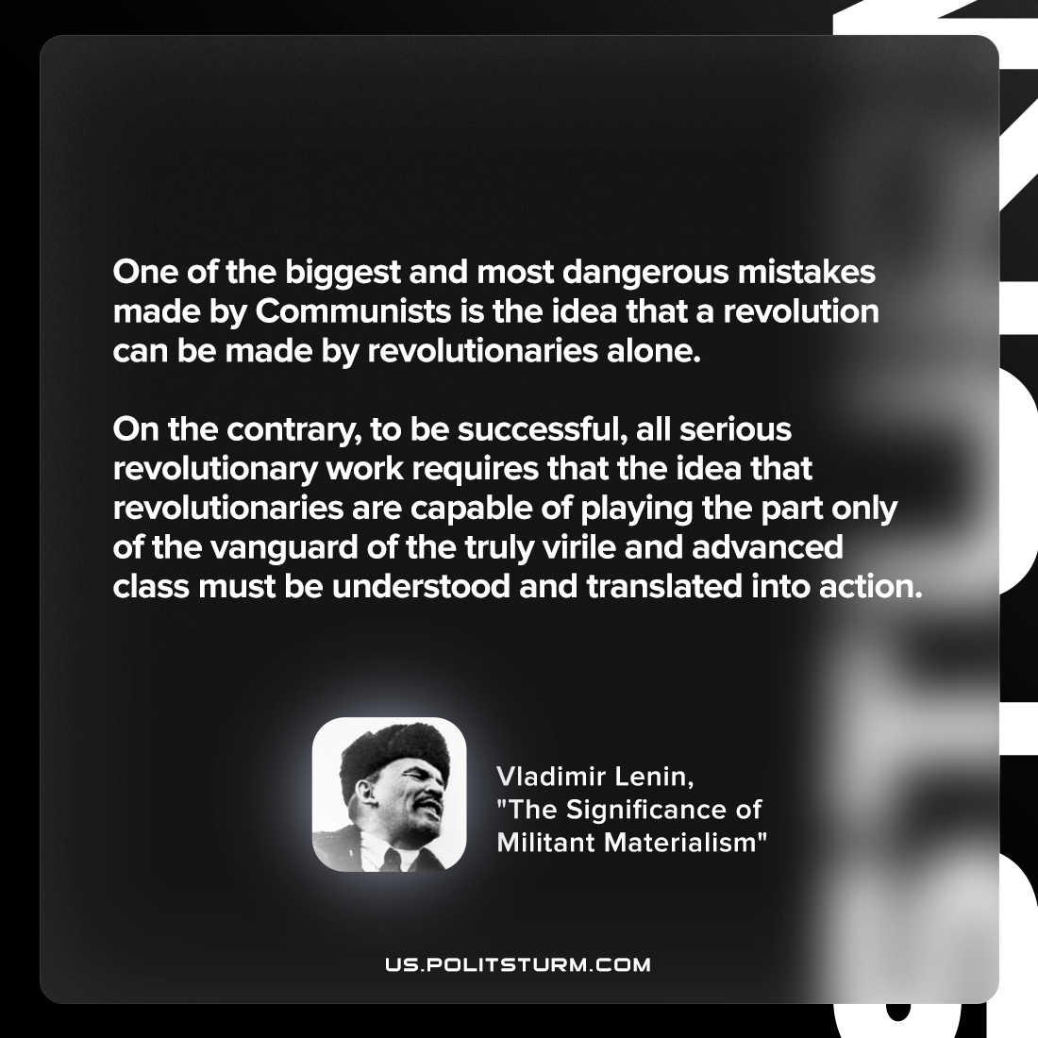

Original article
2022-05-28

One of the biggest and most dangerous mistakes made by Communists is the idea that a revolution can be made by revolutionaries alone. On the contrary, to be successful, all serious revolutionary work requires that the idea that revolutionaries are capable of playing the part only of the vanguard of the truly virile and advanced class must be understood and translated into action.

Vladimir Lenin, “The Significance of Militant Materialism”

Original article

