Lenin on the Revolutionary Path of Russia
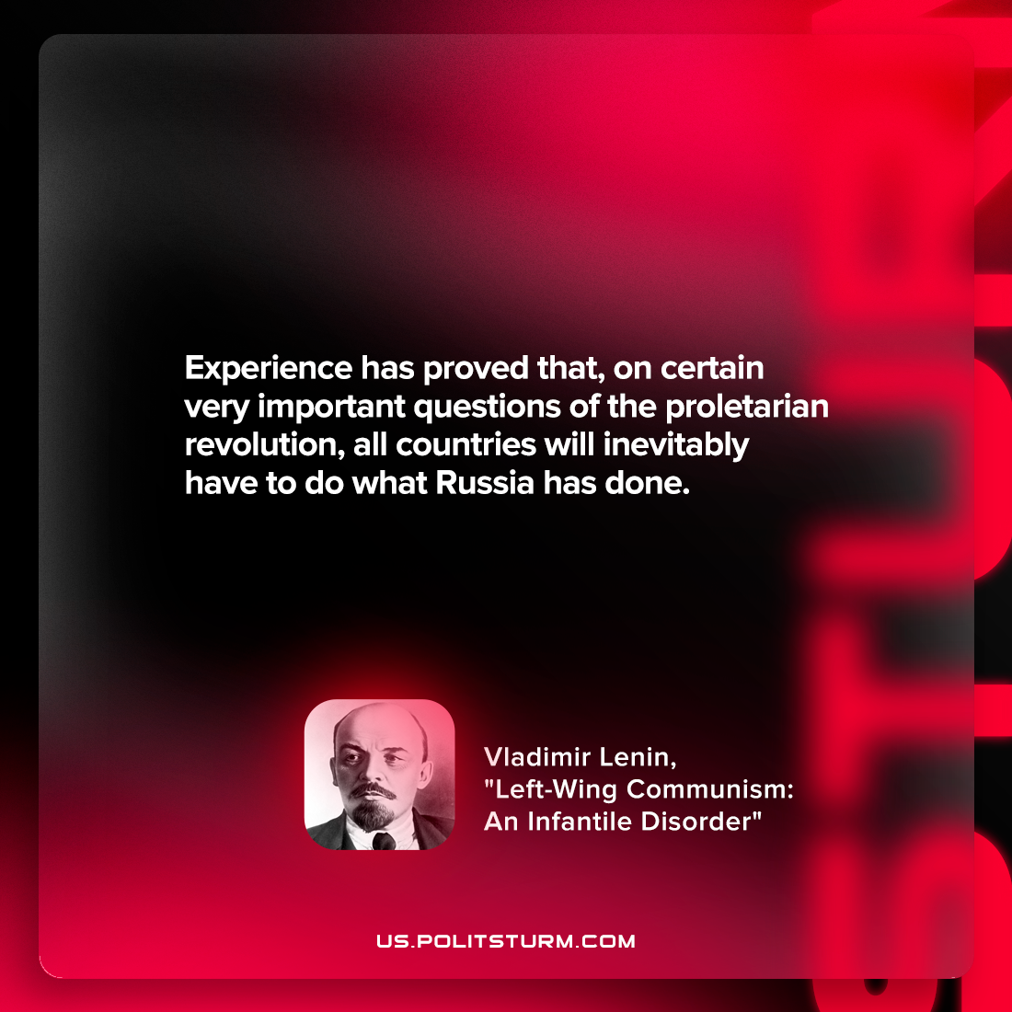

Original article
2022-06-03

Experience has proved that, on certain very important questions of the proletarian revolution, all countries will inevitably have to do what Russia has done.

Vladimir Lenin, “Left-Wing Communism: An Infantile Disorder”

Original article

