Lenin on the Revolutionary Party
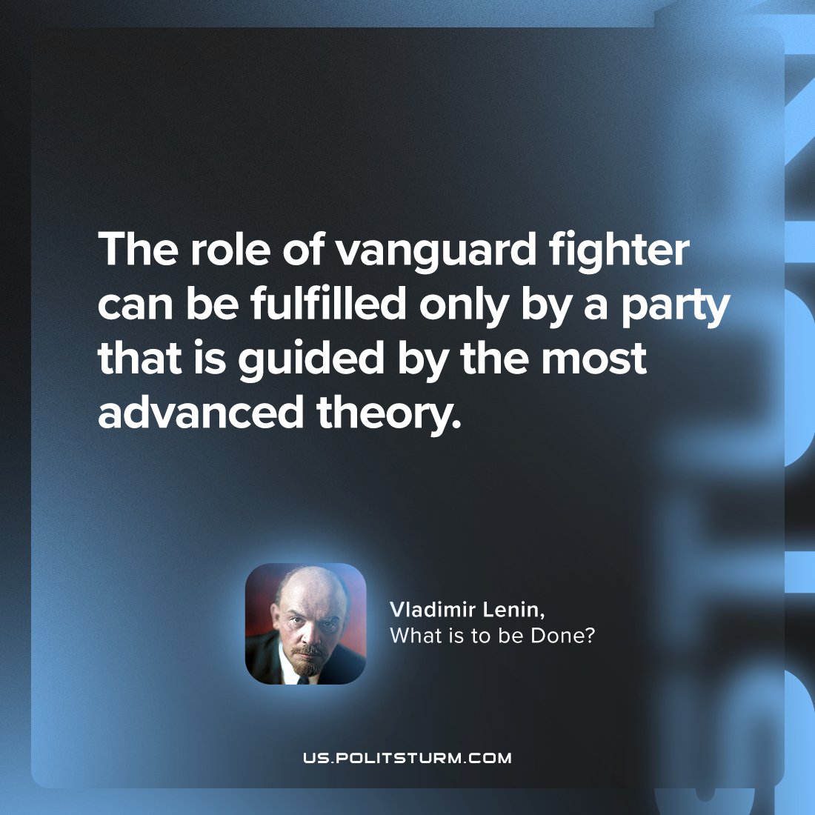

Original article
2023-12-21

"The role of vanguard fighter can be fulfilled only by a party that is guided by the most advanced theory."
Vladimir Lenin, What Is To Be Done?

Original article

