Lenin on the Revolutionary Dictatorship of the Proletariat
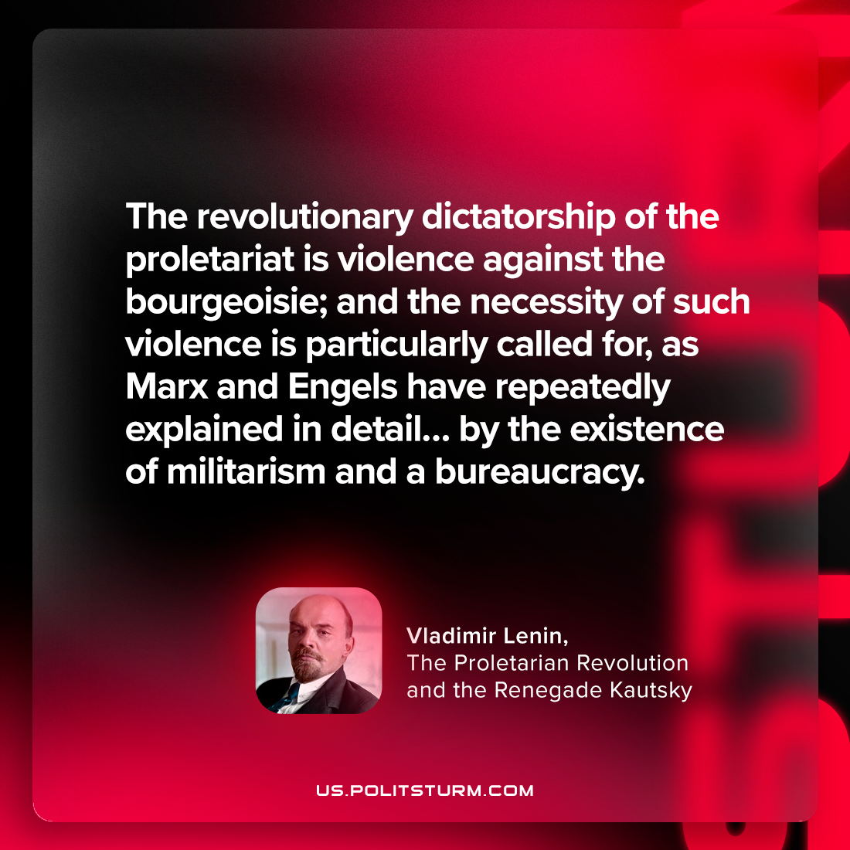

Original article
2024-03-02

"The revolutionary dictatorship of the proletariat is violence against the bourgeoisie; and the necessity of such violence is particularly called for, as Marx and Engels have repeatedly explained in detail… by the existence of militarism and a bureaucracy."
Vladimir Lenin, The Proletarian Revolution and the Renegade Kautsky

Original article

