Lenin on the Revision of Marxism
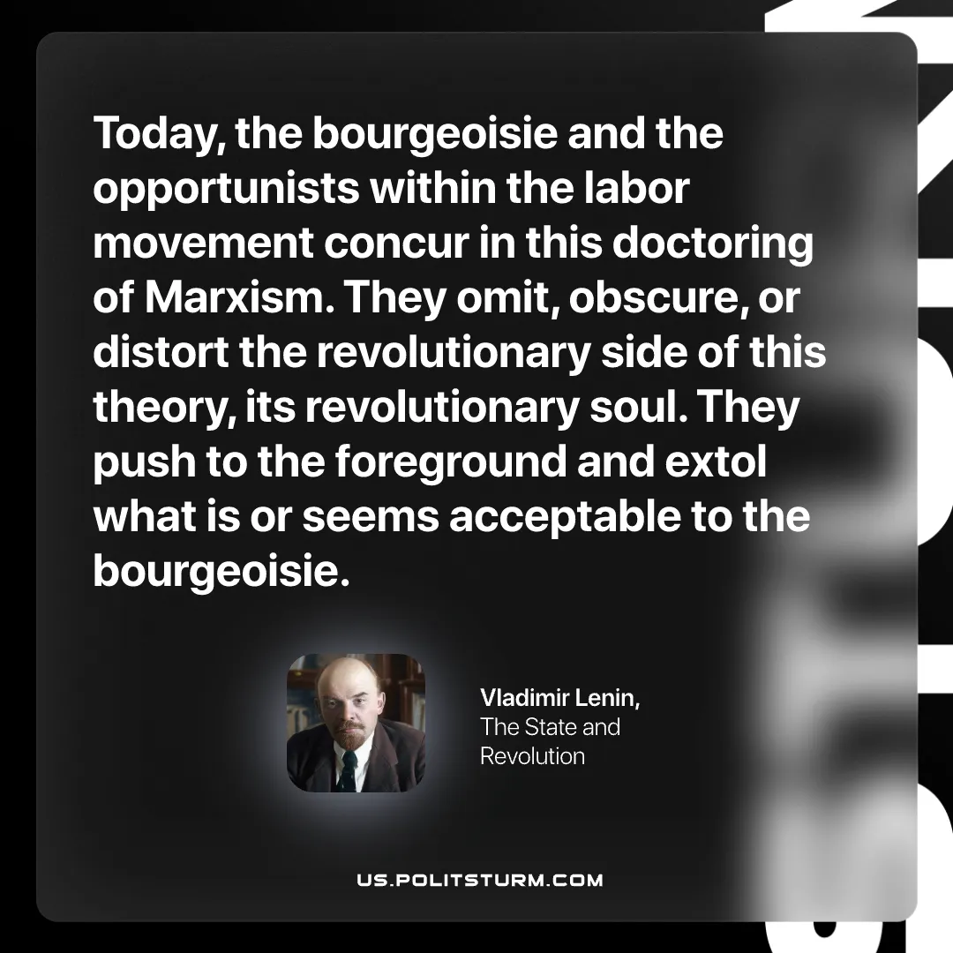

Original article
2026-06-14

Today, the bourgeoisie and the opportunists within the labor movement concur in this doctoring of Marxism. They omit, obscure, or distort the revolutionary side of this theory, its revolutionary soul. They push to the foreground and extol what is or seems acceptable to the bourgeoisie.
Vladimir Lenin, The State and Revolution

Original article

