Lenin on the Reality of "Democratic Republics"
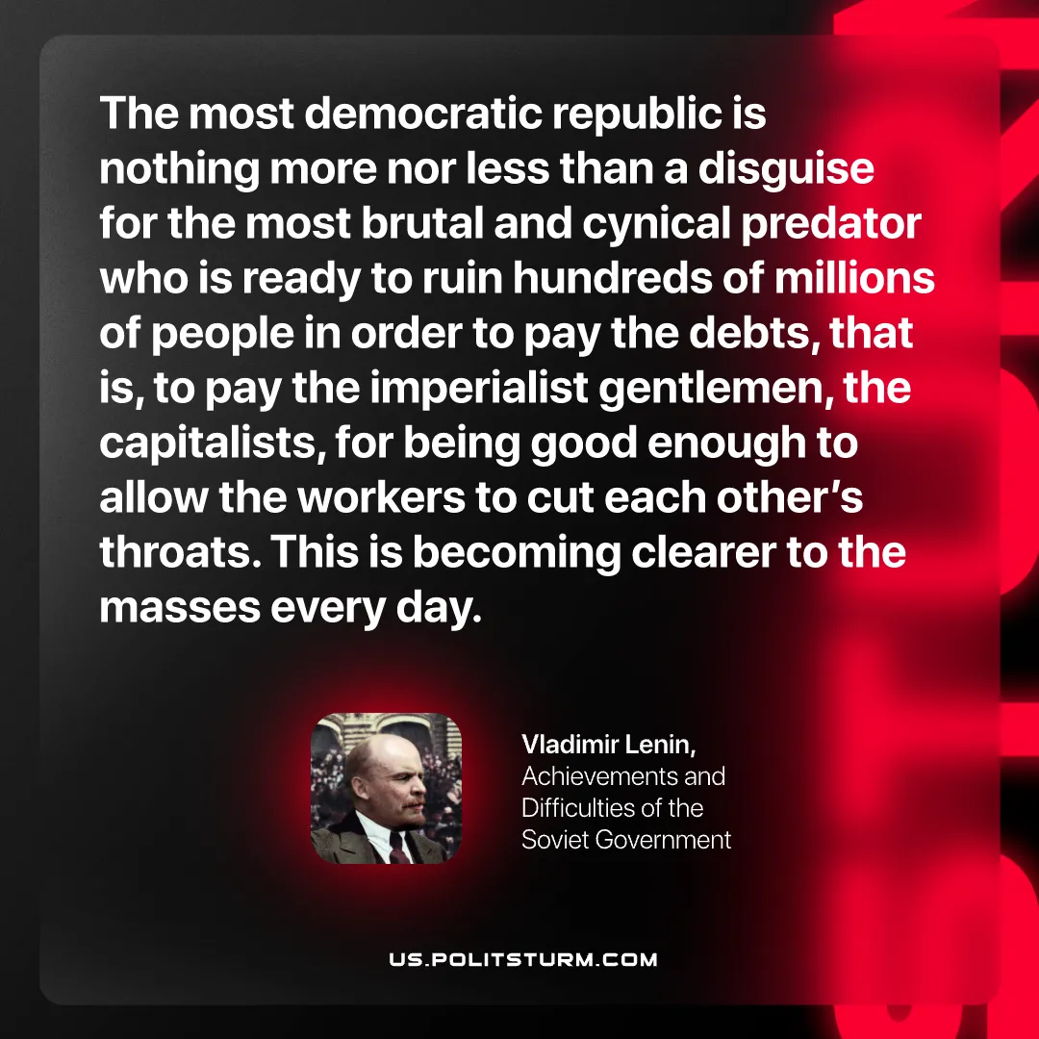

Original article
2026-05-30

The most democratic republic is nothing more nor less than a disguise for the most brutal and cynical predator who is ready to ruin hundreds of millions of people in order to pay the debts, that is, to pay the imperialist gentlemen, the capitalists, for being good enough to allow the workers to cut each other’s throats. This is becoming clearer to the masses every day.
Vladimir Lenin, Achievements and Difficulties of the Soviet Government

Original article

