Lenin on the Real Content of Imperialist Wars
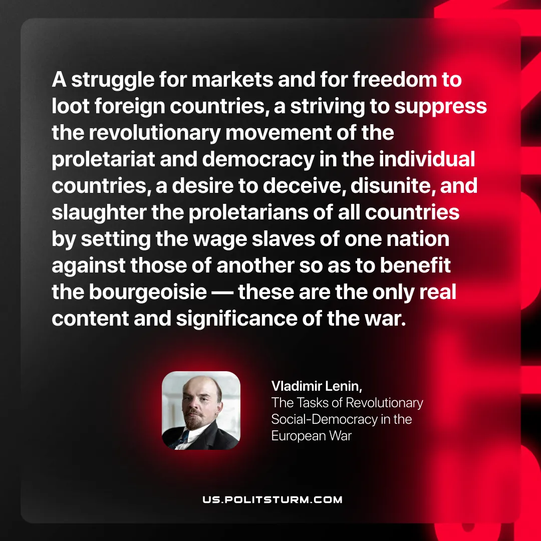

Original article
2025-11-02

A struggle for markets and for freedom to loot foreign countries, a striving to suppress the revolutionary movement of the proletariat and democracy in the individual countries, a desire to deceive, disunite, and slaughter the proletarians of all countries by setting the wage slaves of one nation against those of another so as to benefit the bourgeoisie — these are the only real content and significance of the war.
Vladimir Lenin, The Tasks of Revolutionary Social-Democracy in the European War

Original article

