Lenin on the Reactionary Nature of Capitalist Democracy
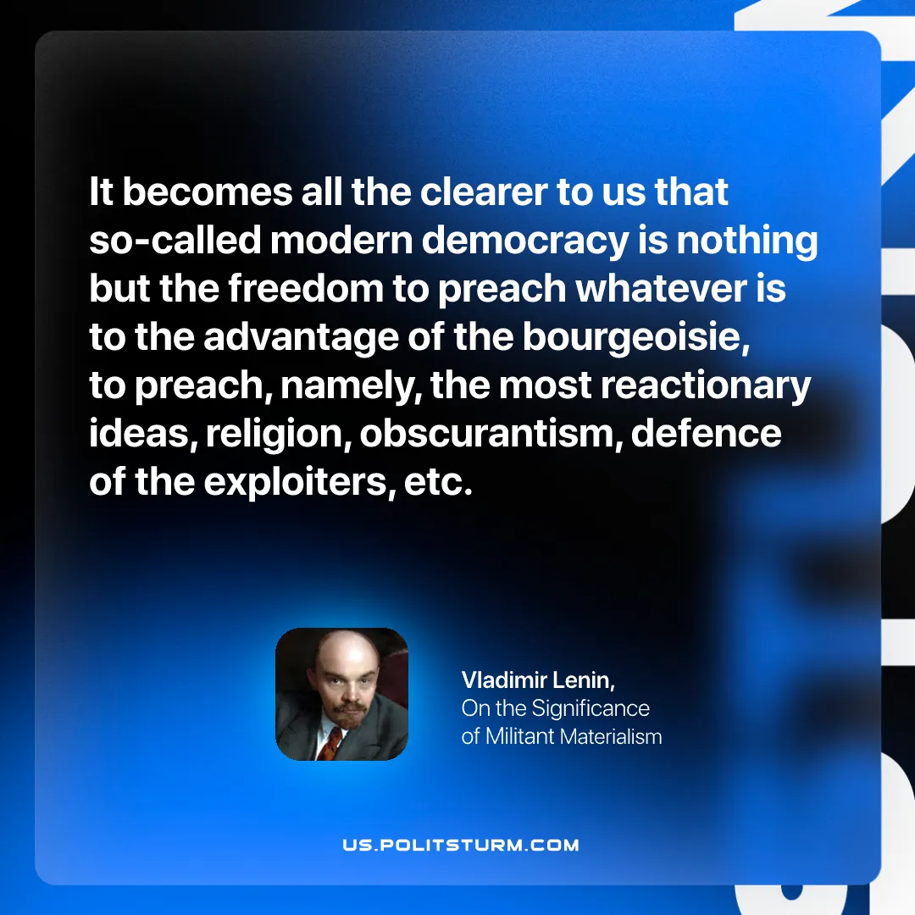

Original article
2025-08-23

“It becomes all the clearer to us that so-called modern democracy is nothing but the freedom to preach whatever is to the advantage of the bourgeoisie, to preach, namely, the most reactionary ideas, religion, obscurantism, defence of the exploiters, etc.”
Vladimir Lenin, On the Significance of Militant Materialism

Original article

