Lenin on the Reaction of the Capitalist to Conflict
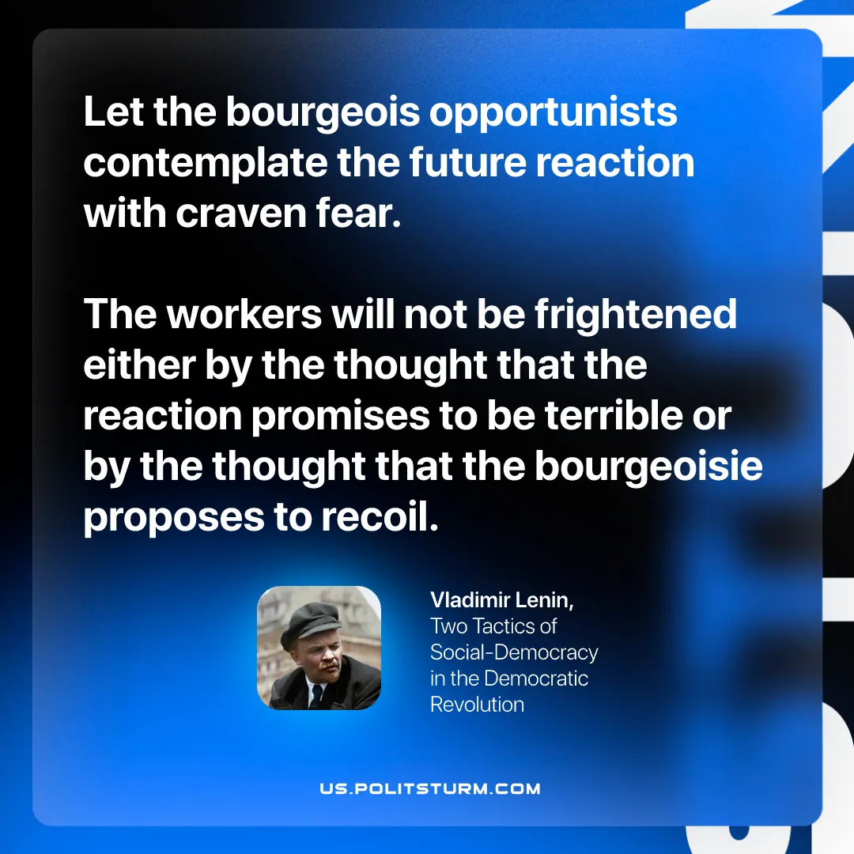

Original article
2026-03-19

“Let the bourgeois opportunists contemplate the future reaction with craven fear. The workers will not be frightened either by the thought that the reaction promises to be terrible or by the thought that the bourgeoisie proposes to recoil.
Vladimir Lenin, Two Tactics of Social-Democracy in the Democratic Revolution

Original article

