Lenin on the Rapid Industrialisation of Capitalism
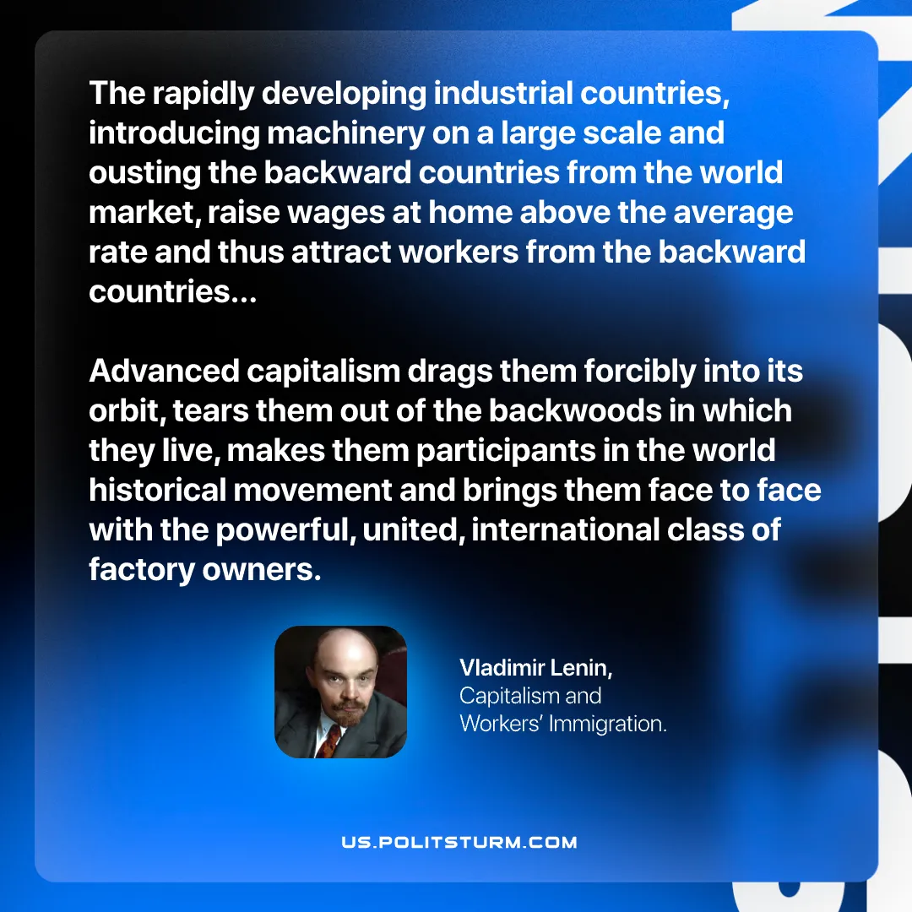

Original article
2026-07-28

The rapidly developing industrial countries, introducing machinery on a large scale and ousting the backward countries from the world market, raise wages at home above the average rate and thus attract workers from the backward countries...
Advanced capitalism drags them forcibly into its orbit, tears them out of the backwoods in which they live, makes them participants in the world historical movement and brings them face to face with the powerful, united, international class of factory owners.
Vladimir Lenin, Capitalism and Workers' Immigration

Original article

