Lenin on the Rallying Force of the Proletariat
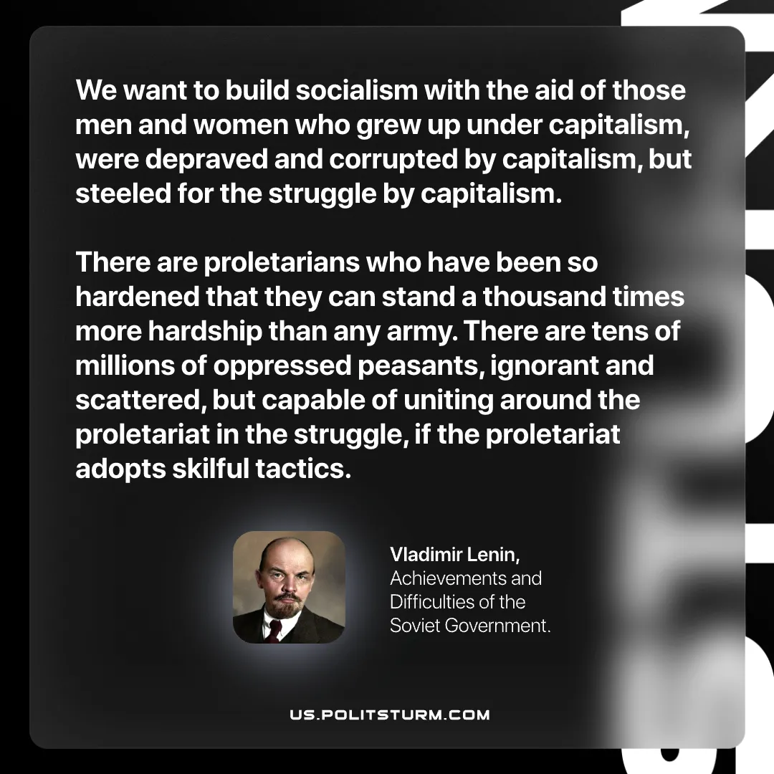

Original article
2026-06-04
1 min read

We want to build socialism with the aid of those men and women who grew up under capitalism, were depraved and corrupted by capitalism, but steeled for the struggle by capitalism.
There are proletarians who have been so hardened that they can stand a thousand times more hardship than any army. There are tens of millions of oppressed peasants, ignorant and scattered, but capable of uniting around the proletariat in the struggle, if the proletariat adopts skilful tactics.
Vladimir Lenin, Achievements and Difficulties of the Soviet Government.

Original article

