Lenin on the Proof We are Right
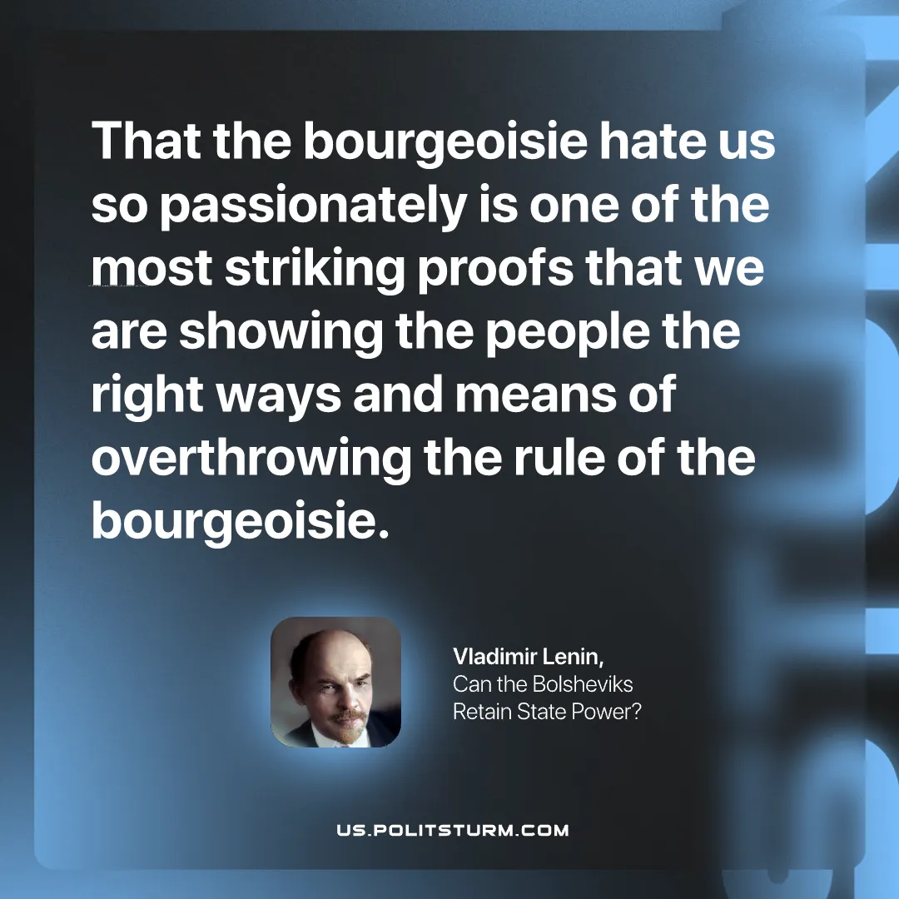

Original article
2026-10-08

That the bourgeoisie hate us so passionately is one of the most striking proofs that we are showing the people the right ways and means of overthrowing the rule of the bourgeoisie.
Vladimir Lenin, Can the Bolsheviks Retain State Power?

Original article

