Lenin on the Proletariat
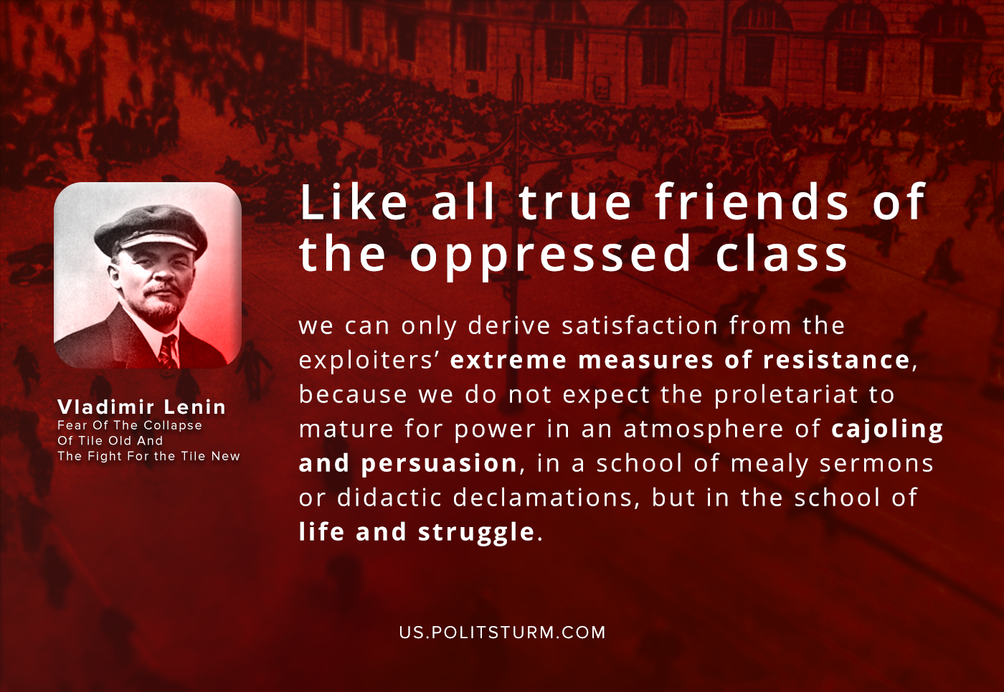

Original article
2020-10-24

Like all true friends of the oppressed class, we can only derive satisfaction from the exploiters’ extreme measures of resistance, because we do not expect the proletariat to mature for power in an atmosphere of cajoling and persuasion, in a school of mealy sermons or didactic declamations, but in the school of life and struggle.
Vladimir Lenin, Fear Of The Collapse Of Tile Old And The Fight For Tile New

Original article

