Lenin on the Proletariat Seizing the Wealth
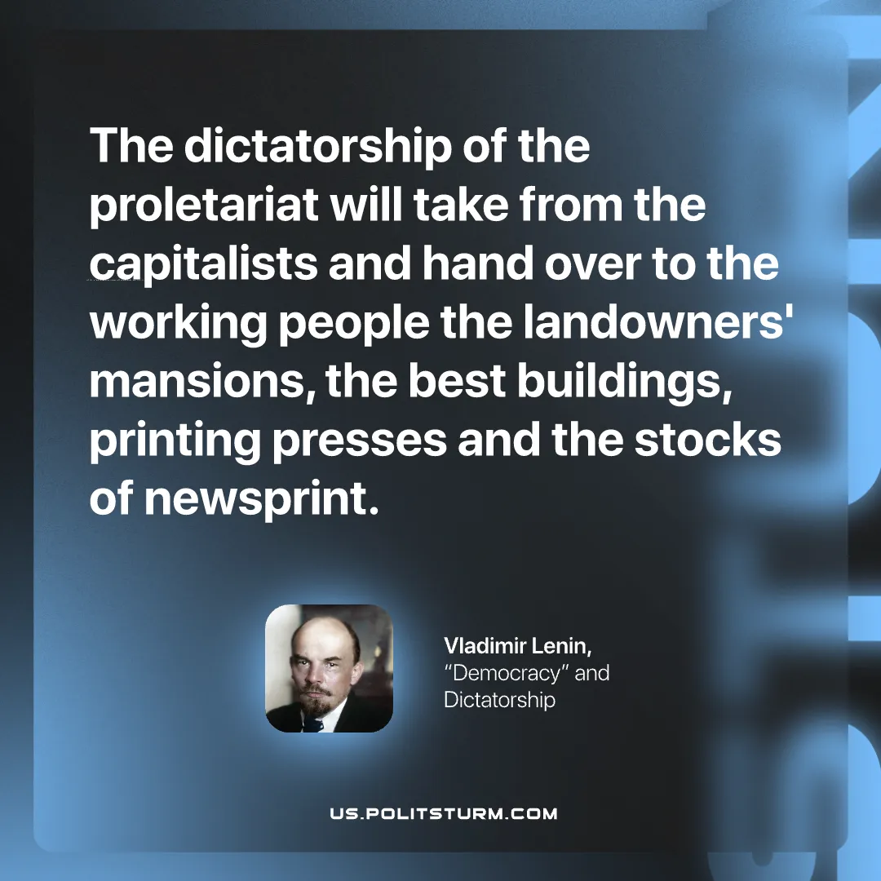

Original article
2026-09-29

The dictatorship of the proletariat will take from the capitalists and hand over to the working people the landowners' mansions, the best buildings, printing presses and the stocks of newsprint.
Vladimir Lenin, "Democracy" and Dictatorship

Original article

